
REPUBLIC OF TÜRKİYE
ALTINBAŞ UNIVERSITY

Computer Engineering Department

TAMIRHANEM: A COMPREHENSIVE AUTO SERVICE
MANAGEMENT PLATFORM
Şevval Nur KASAVET 210502087
Yamaç BEZİRGAN 200502023
Bekir ÇAKIR 210502084

CE491 COMPUTER ENGINEERING GRADUATION PROJECT I
Supervisor
Asst. Prof. Dr. Abdullahi Abdu IBRAHIM
Istanbul, 2026
The Graduation Project titled "TAMIRHANEM: A COMPREHENSIVE AUTO SERVICE MANAGEMENT PLATFORM WITH AI-POWERED ASSISTANCE" prepared by Şevval Nur KASAVET (210502087), Yamaç BEZİRGAN (200502023), and Bekir ÇAKIR (210502084) and submitted on January 2026 has been accepted unanimously.

Asst. Prof. Dr. Abdullahi Abdu IBRAHIM
Supervisor

DECLARATION

I hereby declare that this Project meets all format and submission requirements for a CE491 Computer EngIneerIng GraduatIon Project I.
I hereby declare that all information/data presented in this graduation project has been obtained in full accordance with academic rules and ethical conduct. I also declare all unoriginal materials and conclusions have been cited in the text and all references mentioned in the Reference List have been cited in the text, and vice versa as required by the abovementioned rules and conduct.

Şevval Nur KASAVET
Signature: _______________
Yamaç BEZİRGAN
Signature: _______________
Bekir ÇAKIR
Signature: _______________

ABSTRACT

TAMIRHANEM: A COMPREHENSIVE AUTO SERVICE MANAGEMENT PLATFORM
WITH AI-POWERED ASSISTANCE

KASAVET, Şevval Nur; BEZİRGAN, Yamaç; ÇAKIR, Bekir
B.Sc., Department of Computer Engineering, Altınbaş University
Asst. Prof. Dr. Abdullahi Abdu IBRAHIM
January 2026
Total Page : 54

The automotive service industry in Turkey faces significant challenges in digital transformation, with many businesses still relying on manual paper-based processes for customer management, appointment scheduling, inventory tracking, and financial operations. This inefficiency leads to poor customer communication, inventory management difficulties, and inadequate online presence for service businesses. This graduation project presents Tamirhanem, a comprehensive web-based platform designed to address these challenges through digital transformation of auto service operations.
Tamirhanem is developed as a three-tier architecture platform serving three distinct user roles: customers (vehicle owners), industrialists (auto service business operators), and platform administrators. The system implements a complete solution including Customer Relationship Management (CRM), Enterprise Resource Planning (ERP) functionalities, work order management, digital invoicing with PDF generation, appointment scheduling with calendar integration, maintenance reminder systems, and an innovative AI-powered assistant utilizing Google Gemini API for intelligent customer and business support.
The platform is built using modern web technologies including React 18 with TypeScript for the frontend, Express.js with Node.js for the backend, and PostgreSQL with Prisma ORM for database management. The system implements JWT-based authentication with role-based access control (RBAC), ensuring secure multi-tenant operations. The database schema comprises 21 tables and 17 enumeration types, supporting over 200 RESTful API endpoints.
Key innovations include the business showcase feature providing customizable web presence for service businesses, real-time notification systems, comprehensive review and rating management, and AI-driven assistance for both customers and business operators. The platform successfully demonstrates the potential for digital transformation in the traditional automotive service sector.

Keywords: Auto Service Management, Web Application, CRM, ERP, AI Assistant, React, Node.js, PostgreSQL

TABLE OF CONTENTS

ABSTRACT 4
TABLE OF CONTENTS 6
LIST OF TABLES 8
LIST OF FIGURES 9
ABBREVIATIONS 10
1. INTRODUCTION 11
1.1 Problem Statement 11
1.2 Project Objectives 12
1.3 Project Scope 13
1.4 Document Structure 14
2. LITERATURE REVIEW 16
2.1 Automotive Service Industry Overview 16
2.2 Existing Solutions and Competitors 17
2.3 Web Technologies Review 18
2.4 AI in Customer Service Applications 19
3. METHODOLOGY 21
3.1 Development Methodology 21
3.2 Technology Stack Selection 22
3.3 System Architecture Design 23
3.4 Database Design 24
3.5 API Design 26
3.6 Security Architecture 27
4. SYSTEM DESIGN AND IMPLEMENTATION 29
4.1 Frontend Implementation 29
4.2 Backend Implementation 31
4.3 Database Implementation 32
4.4 Admin Panel Features 33
4.5 Business Panel Features 35
4.6 Customer Panel Features 40
4.7 AI Assistant Implementation 43
5. TESTING AND EVALUATION 45
5.1 Testing Strategy 45
5.2 Functional Testing 45
5.3 User Interface Testing 46
5.4 Performance Evaluation 47
6. CONCLUSION AND FUTURE WORK 48
6.1 Project Summary 48
6.2 Achievements 48
6.3 Limitations 49
6.4 Future Work 49
REFERENCES 51
APPENDIX A: Database Schema 53
APPENDIX B: API Endpoints 55
APPENDIX C: Team Responsibilities 56

LIST OF TABLES

Table 1.1: Project Team Members and Responsibilities 14
Table 2.1: Comparison of Existing Auto Service Management Solutions 17
Table 3.1: Frontend Technology Stack 22
Table 3.2: Backend Technology Stack 22
Table 3.3: Database Tables Overview 25
Table 3.4: Enumeration Types in Database 27
Table 3.5: API Endpoint Categories and Counts 26
Table 4.1: Admin Panel Modules 33
Table 4.2: Business Panel Modules 36
Table 4.3: Customer Panel Modules 40
Table 5.1: Test Scenarios and Results 45
Table 5.2: Performance Metrics 47
Table 6.1: Project Achievement Summary 48

LIST OF FIGURES

Figure 3.1: Three-Tier System Architecture 23
Figure 3.2: System Component Diagram 24
Figure 3.3: Entity-Relationship Diagram 25
Figure 3.4: JWT Authentication Flow 27
Figure 4.1: Landing Page Design 30
Figure 4.2: Login Page Interface 30
Figure 4.3: Registration Page Interface 31
Figure 4.4: Admin Dashboard Overview 34
Figure 4.5: Admin User Management Screen 34
Figure 4.6: Admin Business Management Screen 35
Figure 4.7: Admin Revenue Reports 35
Figure 4.8: Business Dashboard Overview 36
Figure 4.9: Appointment Management - List View 37
Figure 4.10: Appointment Management - Calendar View 37
Figure 4.11: Customer Management (CRM) Interface 38
Figure 4.12: Inventory Management (ERP) Interface 38
Figure 4.13: Work Order Management Screen 39
Figure 4.14: Invoice Management and PDF Generation 39
Figure 4.15: Business Showcase Editor 40
Figure 4.16: Customer Dashboard Overview 41
Figure 4.17: Appointment Booking Interface 41
Figure 4.18: Vehicle Management Screen 42
Figure 4.19: Service History View 42
Figure 4.20: Customer Invoice View 43
Figure 4.21: AI Assistant Chat Interface 44
Figure 4.22: AI Image Analysis Feature 44
Figure 5.1: System Performance Metrics 47

ABBREVIATIONS

AI | : | Artificial Intelligence
API | : | Application Programming Interface
CORS | : | Cross-Origin Resource Sharing
CRM | : | Customer Relationship Management
CSS | : | Cascading Style Sheets
CRUD | : | Create, Read, Update, Delete
DOM | : | Document Object Model
ERP | : | Enterprise Resource Planning
HTML | : | HyperText Markup Language
HTTP | : | HyperText Transfer Protocol
JSON | : | JavaScript Object Notation
JWT | : | JSON Web Token
MVP | : | Minimum Viable Product
ORM | : | Object-Relational Mapping
PDF | : | Portable Document Format
QA | : | Quality Assurance
RBAC | : | Role-Based Access Control
REST | : | Representational State Transfer
SPA | : | Single Page Application
SQL | : | Structured Query Language
UI | : | User Interface
URL | : | Uniform Resource Locator
UUID | : | Universally Unique Identifier
UX | : | User Experience
XSS | : | Cross-Site Scripting

1. INTRODUCTION
The automotive service industry represents a critical sector within the Turkish economy, serving millions of vehicle owners annually. Despite the technological advancements witnessed across various industries, a significant portion of auto service businesses in Turkey continues to rely on traditional, paper-based methods for managing their daily operations. This digital gap creates numerous inefficiencies, including poor customer communication, inventory management challenges, and limited online visibility for service providers.
This graduation project introduces Tamirhanem, a comprehensive web-based platform designed to facilitate the digital transformation of auto service businesses. The platform provides an integrated solution that addresses the core operational needs of automotive service providers while simultaneously enhancing the customer experience through modern digital interfaces and intelligent assistance systems.
The name "Tamirhanem" combines the Turkish words "tamir" (repair) and "hanem" (my home/place), reflecting the platform's mission to create a digital home for auto service management. The platform serves three distinct user categories: vehicle owners seeking convenient service management, auto service business operators requiring comprehensive business tools, and platform administrators responsible for system oversight.

1.1 PROBLEM STATEMENT
The automotive service sector in Turkey faces several interconnected challenges that impede operational efficiency and customer satisfaction. Through preliminary research and stakeholder interviews, the following key problems have been identified:
Manual Process Management: The majority of auto service businesses continue to utilize paper-based systems for appointment scheduling, customer records, and inventory tracking. This approach results in data loss, scheduling conflicts, and administrative inefficiencies. Service technicians often spend valuable time searching through physical files rather than performing their core repair functions.
Customer Communication Deficiencies: Customers frequently remain uninformed about the status of their vehicle repairs. The absence of automated notification systems leads to unnecessary phone calls, customer anxiety, and reduced trust in service providers. This communication gap particularly affects customer retention and referral rates.
Inventory Control Challenges: Parts and supplies inventory tracking remains predominantly manual, resulting in stockouts of critical components, over-ordering of slow-moving items, and difficulty in identifying optimal reorder points. These inefficiencies directly impact service delivery times and business profitability.
Financial Management Complexity: Invoice generation, payment tracking, and financial reporting often involve time-consuming manual processes. The lack of integrated financial tools makes it difficult for business owners to maintain accurate records and gain insights into their financial performance.
Limited Digital Presence: Many auto service businesses lack any form of online presence, making it difficult for potential customers to discover their services, view their offerings, or schedule appointments. This digital invisibility places traditional businesses at a competitive disadvantage in an increasingly connected marketplace.

1.2 PROJECT OBJECTIVES
The primary objective of the Tamirhanem project is to develop a comprehensive, scalable, and user-friendly web platform that addresses the identified challenges in the automotive service industry. The specific objectives are outlined below:
The first objective is to implement a complete digital appointment management system enabling customers to schedule, modify, and cancel service appointments online while providing businesses with calendar-based visualization and management tools.
The second objective is to develop an integrated Customer Relationship Management (CRM) system for auto service businesses, enabling efficient tracking of customer information, vehicle histories, and service records.
The third objective is to create an Enterprise Resource Planning (ERP) module for inventory management, including stock tracking, supplier management, low-stock alerts, and movement history.
The fourth objective is to implement a work order management system that tracks service jobs from initiation through completion, including parts usage and labor tracking.
The fifth objective is to build a comprehensive invoicing system with automatic calculation, PDF generation, and payment tracking capabilities.
The sixth objective is to provide customizable digital showcase pages for businesses, enabling them to establish an online presence with service listings, contact information, and customer reviews.
The seventh objective is to integrate an AI-powered assistant utilizing the Google Gemini API to provide intelligent support for both customers and business operators, including vehicle diagnostics assistance and business analytics.
The eighth objective is to establish a secure, scalable platform architecture implementing modern security practices including JWT authentication and role-based access control.

1.3 PROJECT SCOPE
The scope of the Tamirhanem project encompasses the development of a fully functional web-based platform with the following inclusions and exclusions:

1.3.1 Included Features
The project scope includes three distinct user role implementations (Administrator, Business Operator, and Customer), each with dedicated panels and functionality. The system encompasses comprehensive appointment management with both list and calendar views, a complete CRM system with customer and vehicle database management, an ERP module for inventory and supplier management, a work order tracking system with parts integration, an invoicing system with PDF generation and payment tracking, a review and rating system with business response capabilities, maintenance reminder functionality, a notification center for all user types, customizable business showcase pages with three template options, AI-powered assistant integration for customer and business support, a support ticket system for platform assistance, and a complete platform administration panel with analytics and reporting.

1.3.2 Excluded Features (Future Development)
The following features are explicitly excluded from the current project scope but are identified for potential future development: native mobile applications for iOS and Android platforms, online payment gateway integration, SMS notification capabilities, multi-language support beyond Turkish and English interfaces, and real-time chat functionality between customers and businesses.

1.4 DOCUMENT STRUCTURE
This graduation project report is organized into six main chapters. Chapter 1 provides an introduction to the project, including the problem statement, objectives, and scope. Chapter 2 presents a comprehensive literature review covering the automotive service industry, existing solutions, relevant web technologies, and AI applications in customer service. Chapter 3 details the methodology employed in the project, including the development approach, technology stack selection, system architecture, database design, API design, and security considerations. Chapter 4 describes the system design and implementation in detail, covering frontend and backend development, database implementation, and the specific features of each user panel. Chapter 5 presents the testing strategy and evaluation results, including functional testing, user interface testing, and performance metrics. Chapter 6 concludes the report with a project summary, achievements, limitations, and recommendations for future work.
Table 1.1 presents the project team members and their primary areas of responsibility within the development process.
Table 1.1: Project Team Members and Responsibilities
Team Member | Student ID | Primary Responsibilities
Şevval Nur KASAVET | 210502087 | Customer Panel Development, Frontend Implementation, Quality Assurance and Testing
Yamaç BEZİRGAN | 200502023 | Admin Panel Development, Backend Infrastructure, Database Architecture, Authentication System
Bekir ÇAKIR | 210502084 | Business Panel Development, Backend Services, Work Order and Invoice Systems

2. LITERATURE REVIEW
This chapter presents a comprehensive review of the literature relevant to the Tamirhanem project. The review covers the current state of the automotive service industry, existing digital solutions in the market, the web technologies employed in the project, and the application of artificial intelligence in customer service contexts.

2.1 AUTOMOTIVE SERVICE INDUSTRY OVERVIEW
The automotive aftermarket service industry represents a significant economic sector globally, with particular importance in countries with high vehicle ownership rates such as Turkey. According to industry reports, the Turkish automotive aftermarket was valued at approximately USD 12 billion in 2023, with projections indicating continued growth driven by the increasing average age of vehicles on the road and rising vehicle complexity [1].
The sector comprises diverse service providers ranging from authorized dealership service centers to independent repair shops, commonly referred to as "sanayici" in Turkish. Independent service providers constitute the majority of the market, serving price-conscious consumers who prefer more affordable alternatives to dealership services [2]. However, these independent businesses often lack the technological infrastructure and digital tools available to larger dealership networks.
Within this context, the digital maturity gap between large dealership networks and independent service providers creates both challenges and opportunities. Industry observations suggest that businesses adopting integrated management platforms experience notably improved customer loyalty and reduced administrative overhead [3]. For Tamirhanem's target market of independent Turkish service providers, this gap represents the core problem our platform addresses through accessible, affordable digital tooling designed specifically for their operational scale and requirements.
The COVID-19 pandemic accelerated the need for digital transformation in the automotive service industry. Contactless service scheduling, digital payment options, and online communication channels became essential features rather than conveniences [4]. This shift in consumer expectations has created an opportunity for platforms that can bridge the digital gap for traditional service providers.

2.2 EXISTING SOLUTIONS AND COMPETITORS
Several software solutions exist in the automotive service management space, each with varying degrees of functionality and target markets. This section examines the major existing solutions and identifies the gaps that Tamirhanem aims to address.
Shop-Ware is a cloud-based auto repair shop management system widely used in North America. The platform offers comprehensive features including digital vehicle inspections, customer communication tools, and integrated payment processing. However, the solution is primarily designed for the North American market and lacks localization for Turkish business requirements, including Turkish tax regulations and local payment methods [5].
Mitchell 1 provides ProDemand and Manager SE solutions that combine repair information databases with shop management capabilities. These enterprise-level solutions offer extensive vehicle database integration but require significant investment and technical infrastructure, making them unsuitable for small to medium-sized independent service providers in Turkey [6].
In the Turkish market, local solutions offer basic appointment scheduling and customer record management. However, these solutions typically lack modern user interfaces, mobile responsiveness, AI integration, and comprehensive business management features such as inventory control and financial reporting [7].
Table 2.1 presents a comparative analysis of existing solutions against the features offered by Tamirhanem.
Table 2.1: Comparison of Existing Auto Service Management Solutions
Feature | Shop-Ware | Mitchell 1 | Local Solutions | Tamirhanem
Turkish Localization | No | No | Yes | Yes
CRM System | Yes | Yes | Basic | Yes
Inventory Management | Yes | Yes | Limited | Yes
Work Order System | Yes | Yes | Basic | Yes
AI Assistant | No | No | No | Yes
Business Showcase | No | No | No | Yes
Customer Portal | Limited | Limited | No | Yes
Modern UI/UX | Yes | Moderate | No | Yes
Affordable for SMBs | Moderate | No | Yes | Yes

2.3 WEB TECHNOLOGIES REVIEW
Modern web application development has evolved significantly, with numerous frameworks and technologies available for building scalable, maintainable applications. This section reviews the key technologies selected for the Tamirhanem platform and their relevance to the project requirements.

2.3.1 Frontend Technologies
For Tamirhanem's frontend requirements, React was selected based on its component-based structure that naturally maps to our three-panel architecture. Each panel (admin, business, customer) shares common UI elements such as tables, forms, and navigation components, making reusability essential for our small team's productivity [8]. The framework's efficient update mechanism proved particularly valuable for our dashboard interfaces where appointment lists, stock levels, and financial summaries require frequent refreshes without full page reloads.
TypeScript adoption was driven by our team's parallel development workflow where three developers simultaneously built different panels. The static type definitions created a contract between frontend services and backend API responses, catching integration mismatches during compilation rather than runtime [9]. This proved especially valuable when coordinating the shared data structures for appointments, invoices, and user profiles across all three panel implementations.
Tailwind CSS was chosen to maintain visual consistency across Tamirhanem's three panels developed by different team members. Rather than creating separate stylesheets that might diverge over time, the utility class approach embedded styling decisions directly in components [10]. Combined with shadcn/ui's pre-built accessible components, this enabled rapid UI development while ensuring the admin, business, and customer panels share a cohesive visual language.

2.3.2 Backend Technologies
Node.js selection unified our development language across frontend and backend, reducing the learning curve for team members and enabling shared utility functions and type definitions. For Tamirhanem's expected usage pattern where multiple business operators simultaneously manage appointments and inventory, the runtime's concurrent request handling aligns well with our scalability requirements [11].
Express.js provided the structural foundation for Tamirhanem's API layer through its middleware pipeline architecture. Our implementation chains authentication verification, role-based authorization, request logging, and input validation as discrete middleware functions, enabling clean separation of cross-cutting concerns from business logic [12].
Prisma ORM bridges our TypeScript codebase with the PostgreSQL database through auto-generated type definitions derived from the schema file. For Tamirhanem's 21-table schema with complex relationships between users, appointments, work orders, and invoices, Prisma's type-safe query builder prevents field name typos and relationship navigation errors at compile time [13].

2.3.3 Database Technologies
PostgreSQL was selected over alternatives based on Tamirhanem's specific data modeling requirements. The platform's core workflow connecting appointments to work orders to invoices demands strict referential integrity through foreign key constraints, which PostgreSQL enforces reliably [14]. Additionally, the native JSON column type enabled flexible storage for business showcase customization data and working hours configurations without requiring schema modifications for each customization option.

2.4 AI IN CUSTOMER SERVICE APPLICATIONS
Conversational AI capabilities have become increasingly accessible for integration into business applications through commercial API offerings. For Tamirhanem, incorporating an intelligent assistant addressed a specific user need: customers frequently have questions about maintenance schedules, warning lights, and service requirements that do not necessitate human staff involvement [15].
Google Gemini was selected for Tamirhanem's AI assistant based on three practical criteria: the multimodal capability enabling customers to upload vehicle photos for preliminary issue identification, the straightforward REST API integration compatible with our Express.js backend, and the free tier quota sufficient for development testing and initial deployment phases [16].
The value proposition for Tamirhanem's AI integration centers on reducing repetitive inquiry handling for business operators while providing customers with immediate responses outside business hours [17]. Common questions regarding oil change intervals, tire rotation schedules, and warning light meanings can be addressed automatically, allowing service staff to concentrate on hands-on repair work rather than phone inquiries.
The application of AI in automotive diagnostics has also shown promising results. Computer vision systems can analyze images of vehicle components to identify potential issues, providing valuable preliminary assessments that can guide service decisions [18]. This capability is integrated into Tamirhanem through the AI assistant's image analysis feature.

3. METHODOLOGY
This chapter describes the methodology employed in the development of the Tamirhanem platform. The discussion covers the development approach, technology selection rationale, system architecture design, database schema design, API design principles, and security architecture implementation.

3.1 DEVELOPMENT METHODOLOGY
Tamirhanem's development followed an iterative approach adapted to our academic timeline and three-person team structure. Rather than rigid sprint ceremonies, we implemented weekly synchronization meetings to coordinate interface contracts between the three panels, daily progress updates via Discord messaging, and bi-weekly advisor consultations to validate alignment with graduation project requirements [19].
The development process was organized into phases spanning 18 weeks. The first phase (Weeks 1-2) focused on project planning, requirements analysis, and technology selection. The second phase (Weeks 3-4) involved detailed system design, including database schema design and user interface mockups. The third phase (Weeks 5-8) concentrated on backend infrastructure development, including the authentication system, API architecture, and database implementation. The fourth phase (Weeks 9-12) involved parallel development of the three user panels by the respective team members. The fifth phase (Weeks 13-14) focused on frontend-backend integration and system testing. The sixth phase (Weeks 15-16) was dedicated to quality assurance and bug fixing. The final phase (Weeks 17-18) involved documentation and project delivery.

Version control through Git with GitHub enabled parallel development of the three panels without merge conflicts disrupting progress. Each team member maintained a dedicated branch for their panel, with integration to the main branch occurring after peer review. This workflow proved essential during weeks 9-12 when all three panels were under simultaneous active development.

3.2 TECHNOLOGY STACK SELECTION
The technology stack for Tamirhanem was selected based on several criteria including developer productivity, ecosystem maturity, performance characteristics, community support, and alignment with project requirements. The selected technologies are presented in Tables 3.1 and 3.2.
Table 3.1: Frontend Technology Stack
Technology | Version | Purpose
React | 18.3.1 | User interface framework with component-based architecture
TypeScript | 5.8.3 | Static typing for JavaScript, improving code quality
Vite | 5.4.19 | Build tool providing fast development server and optimized builds
Tailwind CSS | 3.4.17 | Utility-first CSS framework for rapid styling
shadcn/ui | - | Accessible, customizable UI component library (48 components)
TanStack Query | 5.83.0 | Server state management with caching and synchronization
React Router DOM | 6.30.1 | Client-side routing for single-page application
Axios | 1.13.2 | HTTP client for API communication
React Hook Form | 7.61.1 | Form state management with validation support
Zod | 3.25.76 | Schema validation for form inputs
Recharts | 2.15.4 | Data visualization and charting library
Framer Motion | 12.24.8 | Animation library for enhanced user experience

Table 3.2: Backend Technology Stack
Technology | Version | Purpose
Node.js | 18+ | JavaScript runtime environment for server-side execution
Express.js | 4.18.2 | Web application framework for API development
TypeScript | 5.3.3 | Static typing for backend code
Prisma ORM | 7.2.0 | Object-relational mapping with type-safe database access
PostgreSQL | 15+ | Relational database management system
jsonwebtoken | 9.0.3 | JWT token generation and verification
bcrypt | 6.0.0 | Password hashing for secure credential storage
Zod | 4.2.1 | Input validation and schema definition
PDFKit | 0.17.2 | PDF document generation for invoices
Google Generative AI | 0.24.1 | Gemini API integration for AI assistant
Pino | 8.17.2 | High-performance logging
Helmet | 7.1.0 | Security headers middleware

3.3 SYSTEM ARCHITECTURE DESIGN
Tamirhanem's architecture separates concerns across three distinct layers to enable independent development and testing of each tier. This separation allowed our team to work on frontend components while backend API contracts remained stable, and permitted database schema refinements without requiring immediate frontend changes.
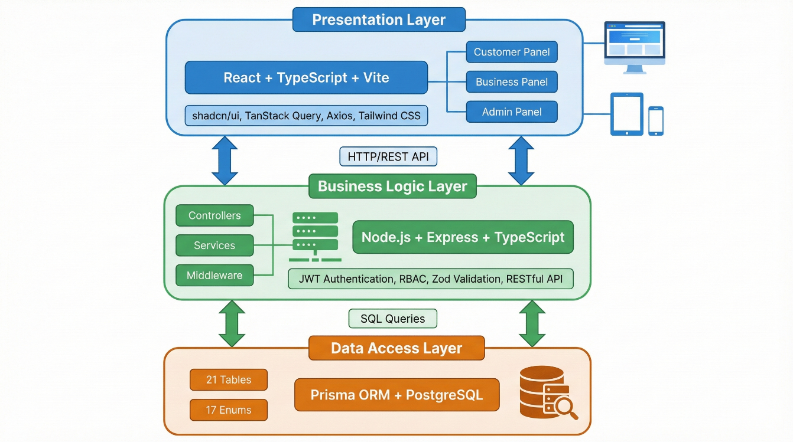Figure 3.1 Three-Tier System Architecture of Tamirhanem Platform
The Presentation Layer is implemented as a React Single Page Application (SPA) responsible for rendering the user interface, handling user interactions, managing client-side state, and communicating with the backend through RESTful API calls. The SPA approach provides a fluid user experience by avoiding full page reloads during navigation.
The Business Logic Layer is implemented using Express.js and comprises controllers that handle HTTP requests, services that implement business logic, middleware for cross-cutting concerns such as authentication and logging, and validators for input sanitization. This layer enforces business rules, manages transactions, and coordinates data flow between the presentation and data access layers.
The Data Access Layer utilizes Prisma ORM to interact with the PostgreSQL database. Prisma provides a type-safe query builder that generates optimized SQL queries while preventing SQL injection attacks through parameterized queries. The data layer also handles connection pooling and transaction management.
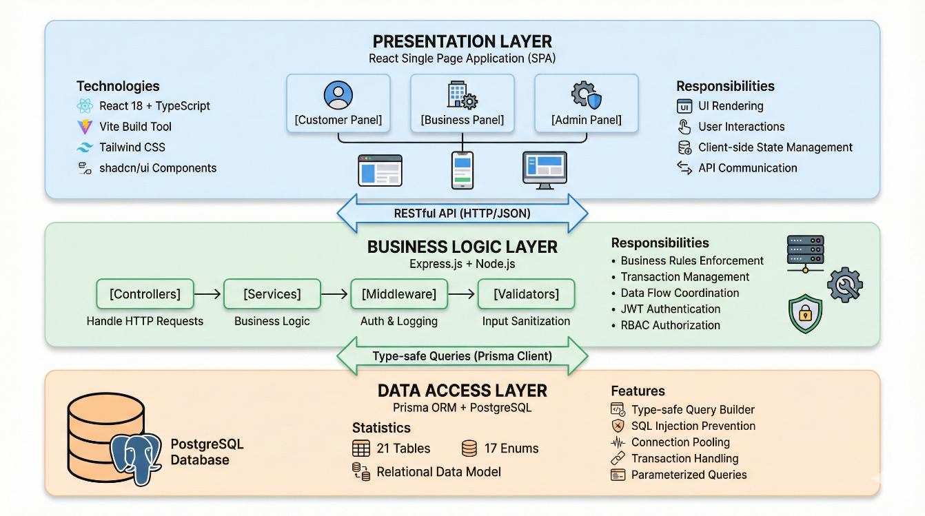Figure 3.2 System Component Architecture and Layer Responsibilities

3.4 DATABASE DESIGN
The database design for Tamirhanem was developed through an iterative process of requirements analysis, entity identification, relationship mapping, and normalization. The resulting schema comprises 21 tables and 17 enumeration types, designed to support the platform's comprehensive functionality while maintaining data integrity and query performance.
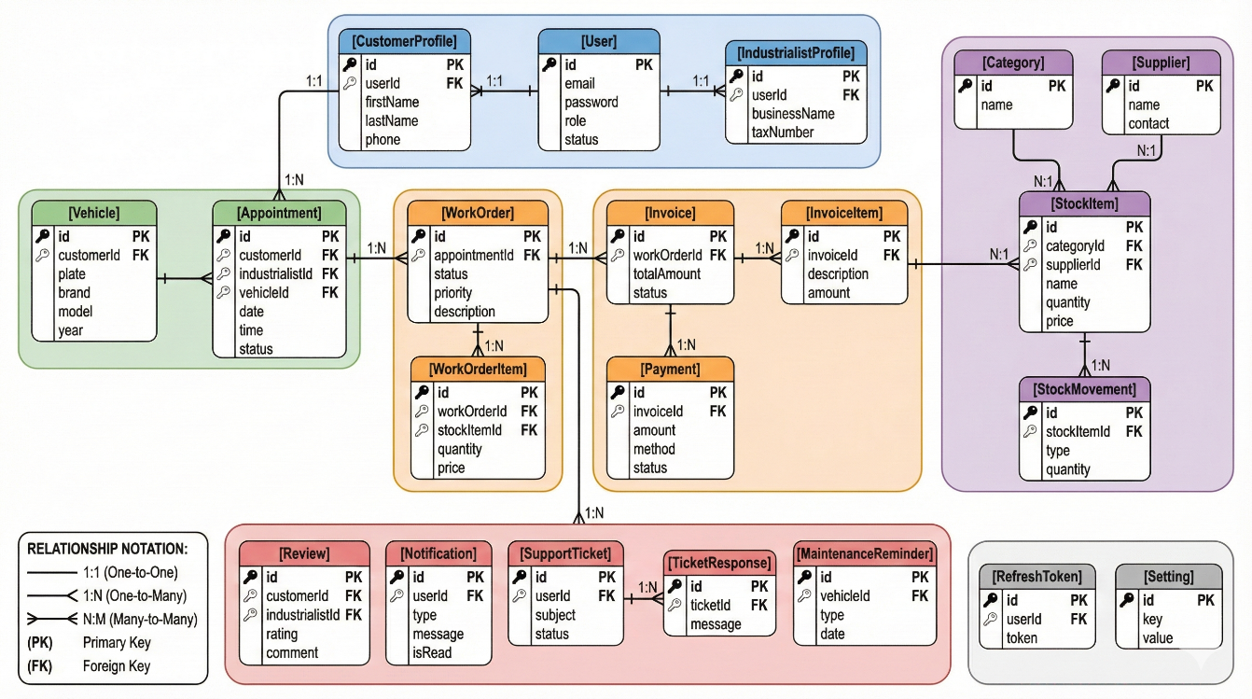Figure 3.3 presents the Entity-Relationship diagram showing the 21 database tables and their relationships. Tables are color-coded by functional domain: user management (blue), appointments (green), work orders and invoicing (orange), inventory (purple), and support services (red).
Table 3.3 provides an overview of the database tables and their primary functions within the system.
Table 3.3: Database Tables Overview
Table Name | Description | Key Relationships
User | Core user account information and authentication credentials | 1:1 with CustomerProfile, IndustrialistProfile
CustomerProfile | Extended profile information for customer users | 1:N with Vehicle, Appointment, Invoice
IndustrialistProfile | Business information for service providers | 1:N with Appointment, StockItem, WorkOrder
Vehicle | Customer vehicle information | N:1 with CustomerProfile
Appointment | Service appointment records | 1:1 with WorkOrder, Review
WorkOrder | Service job tracking | 1:N with WorkOrderItem, 1:1 with Invoice
Invoice | Billing documents | 1:N with InvoiceItem, Payment
StockItem | Inventory items | N:1 with Category, Supplier
Review | Customer ratings and reviews | N:1 with CustomerProfile, IndustrialistProfile
Notification | System notifications to users | N:1 with User
SupportTicket | Customer support requests | 1:N with TicketResponse

3.5 API DESIGN
The Tamirhanem API follows RESTful design principles, providing a consistent and intuitive interface for client-server communication. The API implements standard HTTP methods (GET, POST, PUT, PATCH, DELETE) with appropriate status codes and structured JSON response formats.
The URL structure follows the pattern /api/{resource} for collection operations and /api/{resource}/{id} for individual resource operations. Sub-resources are accessed through nested paths such as /api/work-orders/{id}/items. Statistics and aggregate data are available through dedicated endpoints like /api/{resource}/stats.
All API responses follow a consistent format including a success boolean, a message string, the data payload, and pagination information where applicable. Error responses include appropriate HTTP status codes and descriptive error messages to facilitate debugging and user feedback.
Table 3.5: API Endpoint Categories and Counts
Category | Base Path | Endpoint Count | Description
Authentication | /api/auth | 6 | User registration, login, token management
Admin | /api/admin | 60+ | Platform management, analytics, user control
Customer Portal | /api/portal | 30 | Customer-facing operations
Appointments | /api/appointments | 9 | Scheduling operations
Work Orders | /api/work-orders | 9 | Service job management
Invoices | /api/invoices | 10 | Billing and payment operations
Stock | /api/stock | 15 | Inventory management
AI Assistant | /api/ai | 5 | AI chat and suggestions
Total | - | 200+ | Complete API surface

3.6 SECURITY ARCHITECTURE
Security is a critical aspect of the Tamirhanem platform, given the sensitive nature of customer and business data handled by the system. The security architecture implements multiple layers of protection following industry best practices and security standards.

3.6.1 Authentication System
Tamirhanem's authentication employs a dual-token mechanism calibrated for our multi-role platform. The 7-day access token lifetime balances security with convenience for business operators accessing the platform daily, while the 30-day refresh token stored in the RefreshToken table enables session continuity. The token payload containing userId, email, and role allows each API request to be authorized without database lookup, reducing latency for authenticated operations.
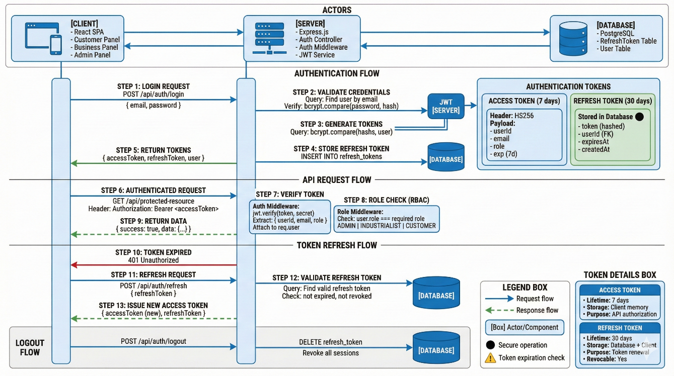Figure 3.4 depicts the JWT authentication flow with dual-token strategy. The diagram shows the complete lifecycle: user login with bcrypt password verification, access token (7 days) and refresh token (30 days) generation, authenticated API requests with RBAC middleware, token refresh mechanism, and logout with session revocation.

Password storage utilizes bcrypt hashing with cost factor 12, selected to balance computational overhead with security requirements for our expected user base. The registration form enforces an 8-character minimum with mandatory uppercase, lowercase, and numeric characters, validated client-side through Zod schemas before server submission.

3.6.2 Authorization and Access Control
Authorization logic enforces three distinct access levels corresponding to Tamirhanem's user types. ADMIN users access platform-wide management functions including user approval and revenue reporting. INDUSTRIALIST users access their own business data including customers, inventory, and invoices. CUSTOMER users access personal vehicles, appointments, and service history. A roleGuard middleware intercepts protected route requests, comparing the authenticated user's role against endpoint requirements before permitting access.

3.6.3 Data Protection
Every API endpoint validates incoming data through Zod schemas defined in dedicated validator files, rejecting malformed requests before they reach service layer processing. Prisma's query builder constructs parameterized SQL statements automatically, eliminating manual string concatenation that could enable injection attacks. On the frontend, React's JSX rendering escapes dynamic content by default, mitigating script injection through user-submitted text fields.
The Express application applies Helmet.js middleware to inject protective HTTP headers preventing clickjacking, MIME sniffing, and enforcing HTTPS connections. CORS middleware restricts API access to requests originating from our frontend domain, blocking attempts to access Tamirhanem's API from unauthorized external applications or scripts.

4. SYSTEM DESIGN AND IMPLEMENTATION
This chapter presents the detailed design and implementation of the Tamirhanem platform. The discussion covers the frontend architecture and component design, backend service implementation, database realization, and the specific features developed for each user panel.

4.1 FRONTEND IMPLEMENTATION
The frontend of Tamirhanem is implemented as a React Single Page Application (SPA) with TypeScript, providing a type-safe development experience. The application comprises 141 React components organized into logical categories based on functionality and user role.

4.1.1 Component Architecture
The component architecture follows a hierarchical structure with shared UI components at the base, feature-specific components in the middle layer, and page components at the top. The shadcn/ui library provides 48 accessible, customizable base components built on Radix UI primitives, ensuring consistent styling and accessibility compliance.
The components are organized into the following directories: admin/ containing 35 components for the administration panel, dashboard/ containing 45 components for the business panel, customer/ containing 6 high-level components for the customer panel, ui/ containing 48 shadcn/ui base components, templates/ containing 3 showcase template components, layout/ containing navigation and structure components, and ai/ containing the AI assistant chat interface components.

4.1.2 Landing Page Design
The landing page serves as the primary entry point for the platform, designed to communicate the value proposition of Tamirhanem to potential users. The page features a hero section with animated elements using Framer Motion, a features section highlighting benefits for both customers and businesses, a pricing section presenting subscription tiers, and a footer with contact information and legal links.
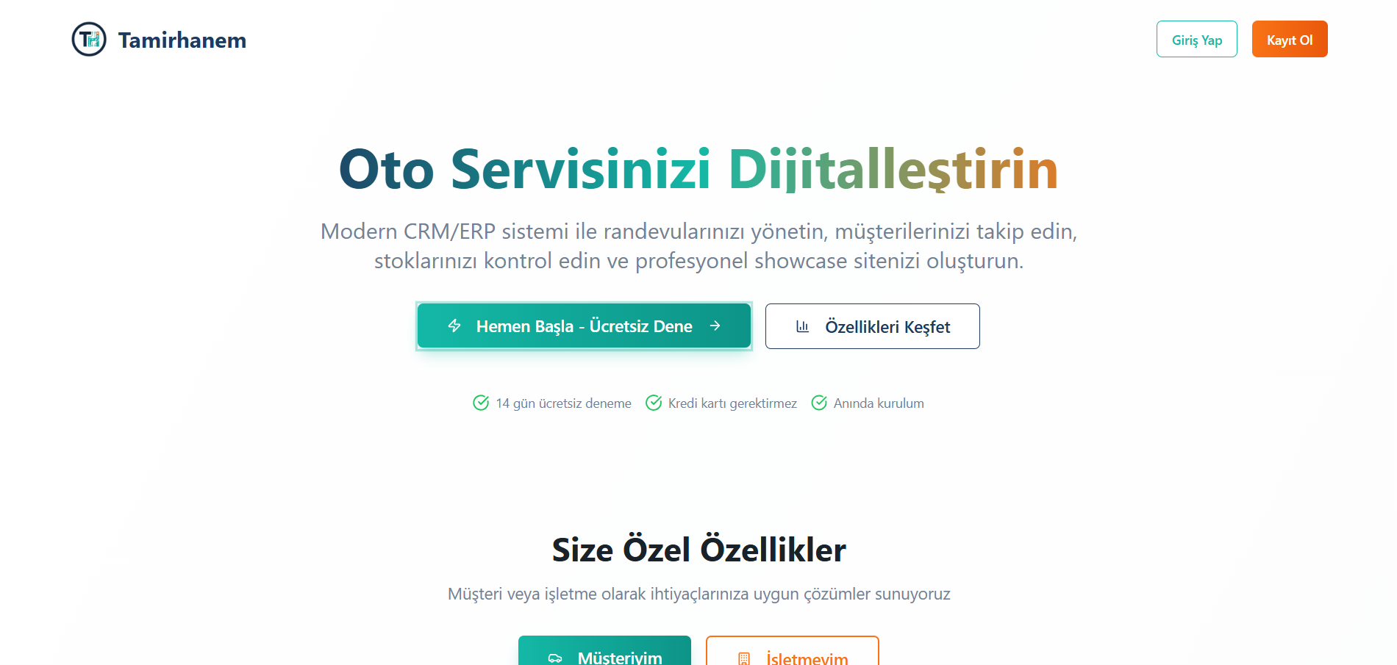
Figure 4.1

4.1.3 Authentication Pages
The login and registration pages implement modern form handling with React Hook Form and Zod validation. The registration flow supports role selection, allowing users to register as either customers or business operators with appropriate profile information collection.
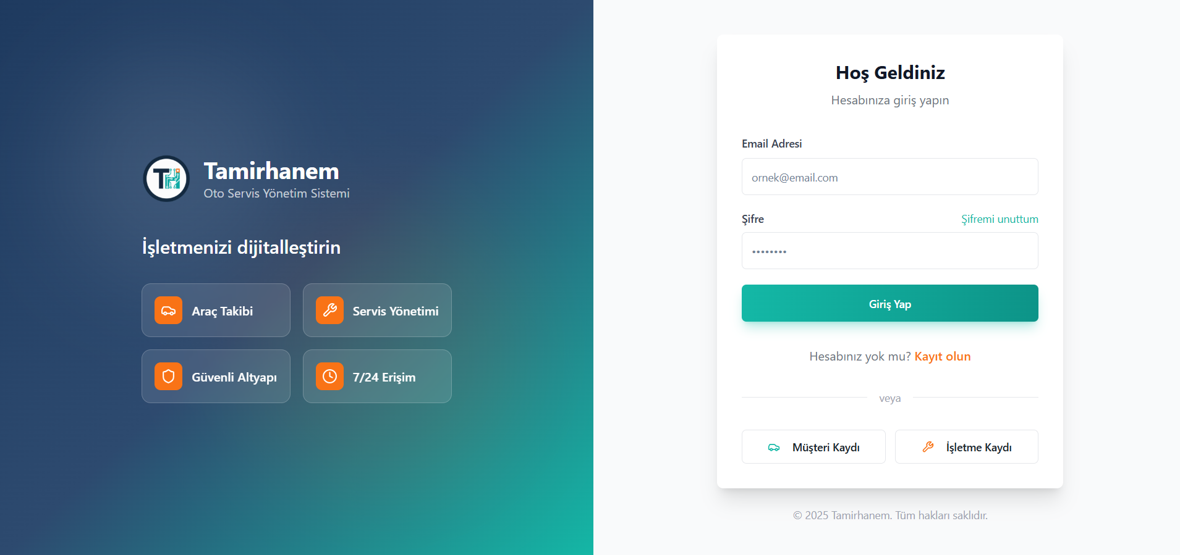Figure 4.2
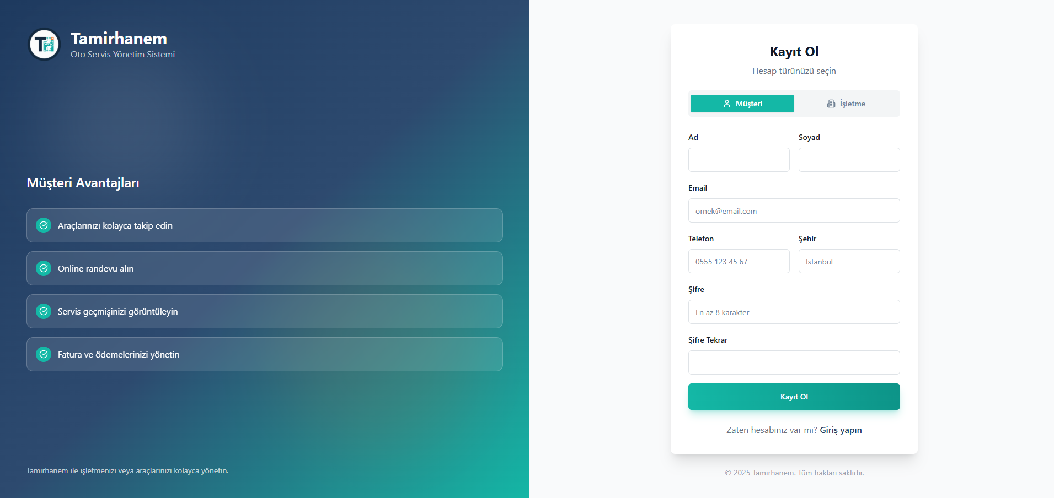Figure 4.3

4.1.4 State Management
Client-side state management utilizes TanStack Query (formerly React Query) for server state, providing automatic caching, background refetching, and optimistic updates. Local UI state is managed through React's built-in useState and useContext hooks. Custom hooks abstract common data fetching patterns, including useCustomers, useAppointments, useStock, and useInvoices.

4.1.5 Routing and Navigation
React Router DOM handles client-side routing with protected route components that verify authentication status and user roles before rendering protected content. The routing structure separates public routes (landing, login, register), customer routes (/customer/*), business routes (/dashboard/*), and admin routes (/admin/*).

4.2 BACKEND IMPLEMENTATION
The backend is structured following a layered architecture with clear separation between controllers, services, and data access. This structure promotes code reusability, testability, and maintainability.

4.2.1 Controller Layer
The controller layer comprises 14 controller files responsible for handling HTTP requests, extracting request parameters, invoking appropriate services, and formatting responses. Controllers implement input validation using Zod schemas before processing requests. Each controller follows consistent patterns for error handling and response formatting.

4.2.2 Service Layer
The service layer contains 16 service files implementing business logic. Services are responsible for data transformation, business rule enforcement, and coordination of complex operations. The separation of services from controllers allows for easier unit testing and potential reuse across different API endpoints.

4.2.3 Middleware Layer
The middleware layer handles cross-cutting concerns including authentication verification through JWT token validation, role-based authorization through role guard middleware, request logging using Pino logger, and centralized error handling with appropriate HTTP status codes.

4.3 DATABASE IMPLEMENTATION
The database implementation translates the designed schema into a functional PostgreSQL database using Prisma ORM. The Prisma schema file defines all 21 models with their fields, relationships, and constraints.
The User model serves as the central authentication entity, storing email, password hash, role, and status information. One-to-one relationships connect User to either CustomerProfile or IndustrialistProfile based on the user's role. The CustomerProfile model extends User with customer-specific fields including name, contact information, and aggregate statistics such as total visits and total spending.
The IndustrialistProfile model contains comprehensive business information including business name, owner details, contact information, working hours stored as JSON, service offerings, subscription details, and showcase configuration. The showcase feature utilizes JSON fields for flexible data storage of customizable content.
The appointment-to-invoice workflow is supported through carefully designed relationships. An Appointment can generate a WorkOrder, which tracks the service job with associated WorkOrderItems. Upon completion, a WorkOrder can generate an Invoice with InvoiceItems, and Payments are recorded against Invoices.

4.4 ADMIN PANEL FEATURES
The admin panel, developed by Yamaç BEZİRGAN, provides platform administrators with comprehensive tools for managing users, businesses, and platform operations. The panel implements over 60 API endpoints covering all administrative functions.
Table 4.1: Admin Panel Modules
Module | Description | Key Features
Dashboard | Platform overview and statistics | User counts, appointment metrics, revenue summary, activity feed
User Management | User account administration | List, search, filter, status changes, role management
Business Management | Service provider oversight | Verification, approval, suspension, detail editing
Showcase Management | Business showcase approval | Pending approvals, status updates, preview
Appointments | Platform-wide appointment view | Filtering, statistics, status overview
Invoices | Financial document oversight | Status tracking, payment monitoring, statistics
Revenue Reports | Financial analytics | Daily/weekly/monthly charts, top performers
Support Tickets | Customer support management | Ticket queue, responses, assignment, status
Settings | Platform configuration | General settings, contact info, feature toggles
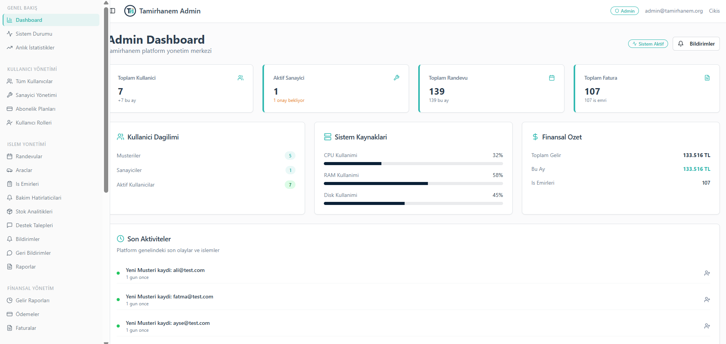Figure 4.4
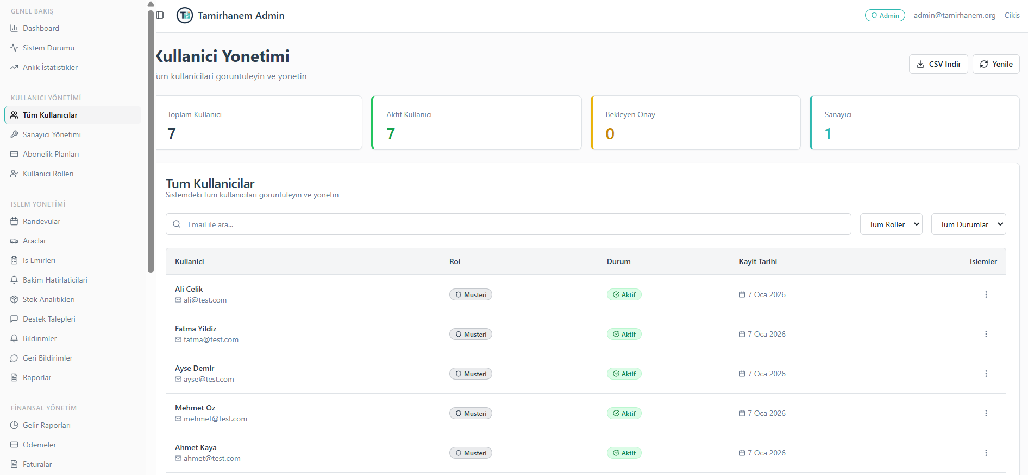Figure 4.5
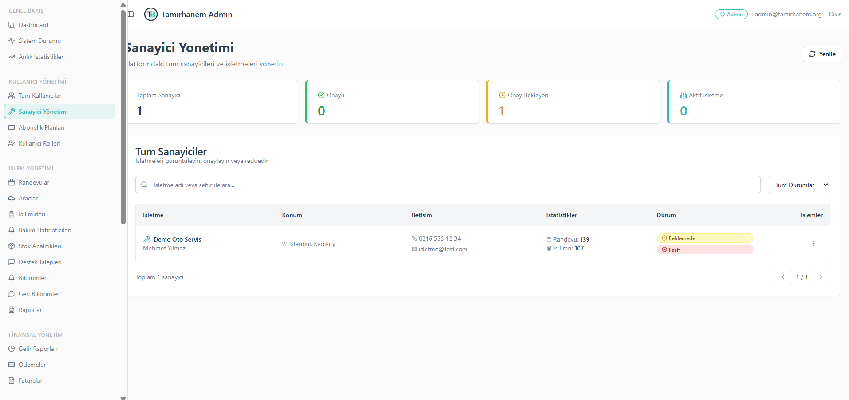Figure 4.6
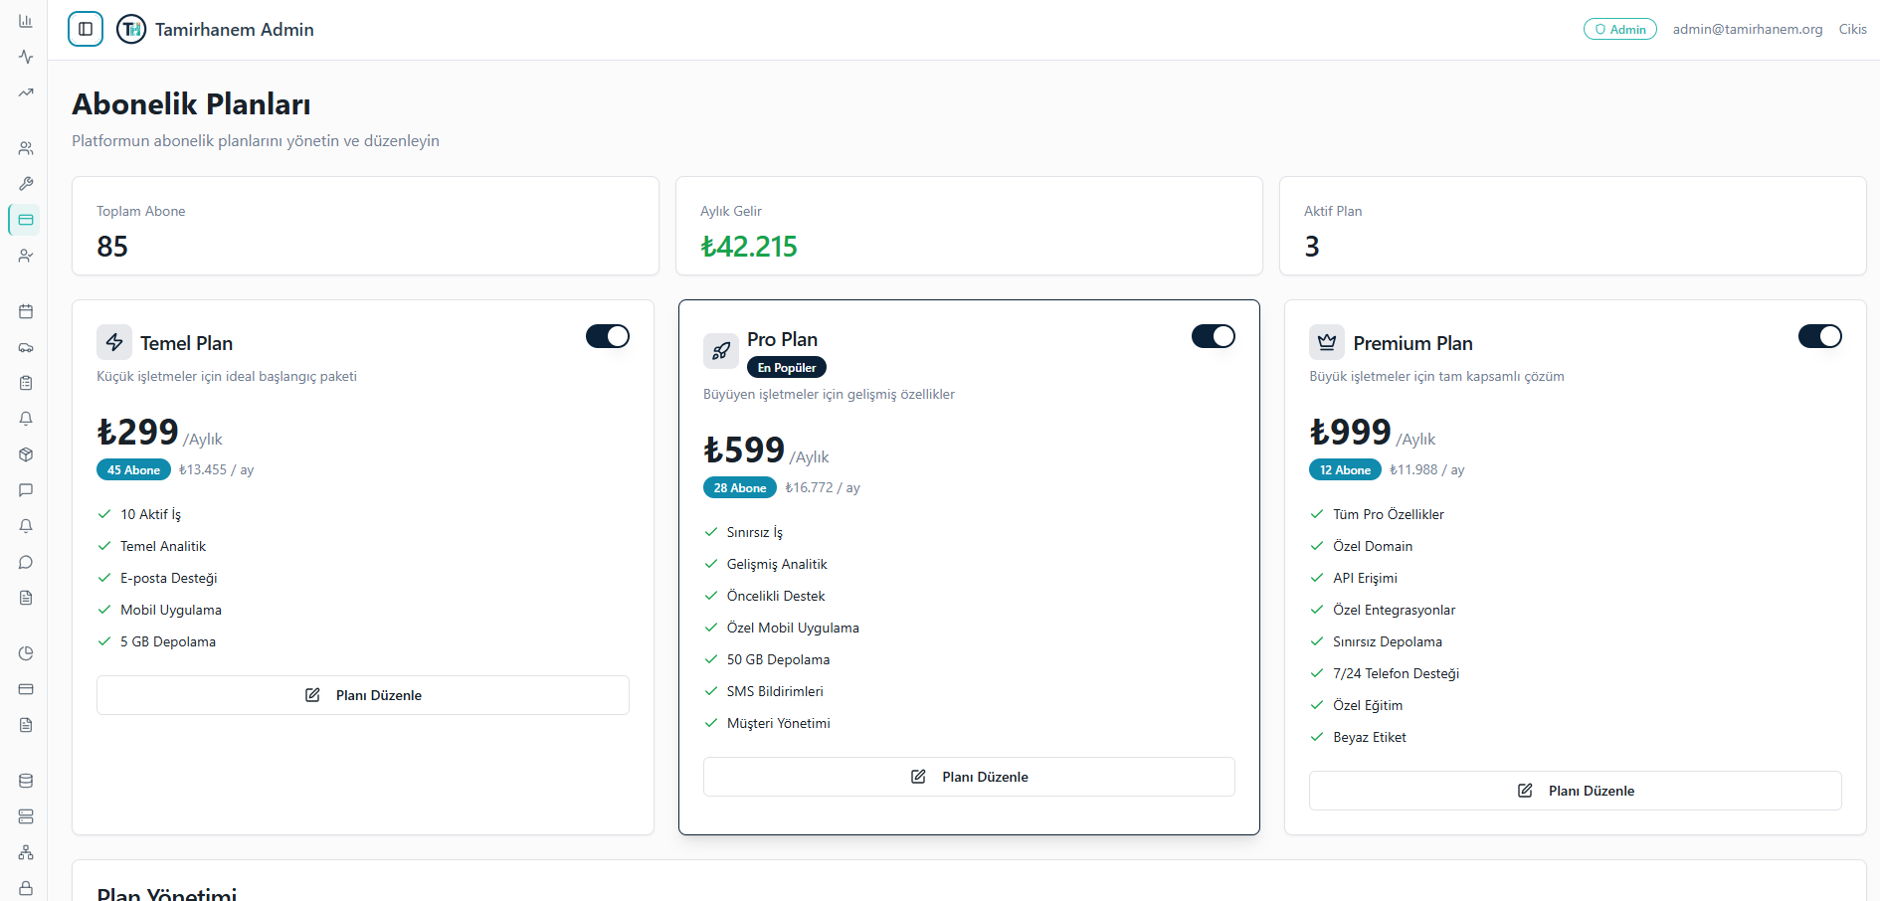Figure 4.7

4.5 BUSINESS PANEL FEATURES
The business panel, developed by Bekir ÇAKIR, provides auto service operators with comprehensive tools for managing their daily operations. The panel implements CRM, ERP, work order management, and invoicing functionalities.

Table 4.2: Business Panel Modules
Module | Description | Key Features
Dashboard | Business overview | Today's appointments, monthly revenue, customer count, ratings
Appointments - List | Appointment management | Filtering, status updates, creation, customer details
Appointments - Calendar | Visual scheduling | Weekly calendar view, drag-drop, color coding
Customer Management | CRM functionality | Customer database, vehicle history, contact management
Inventory Management | ERP functionality | Stock items, categories, suppliers, movements, alerts
Work Orders | Service job tracking | Creation, parts addition, status tracking, technician assignment
Invoices | Billing management | Invoice creation, PDF generation, payment recording
Reviews | Reputation management | Customer reviews, response capability, visibility control
Showcase | Online presence | Template selection, content editing, preview, publishing
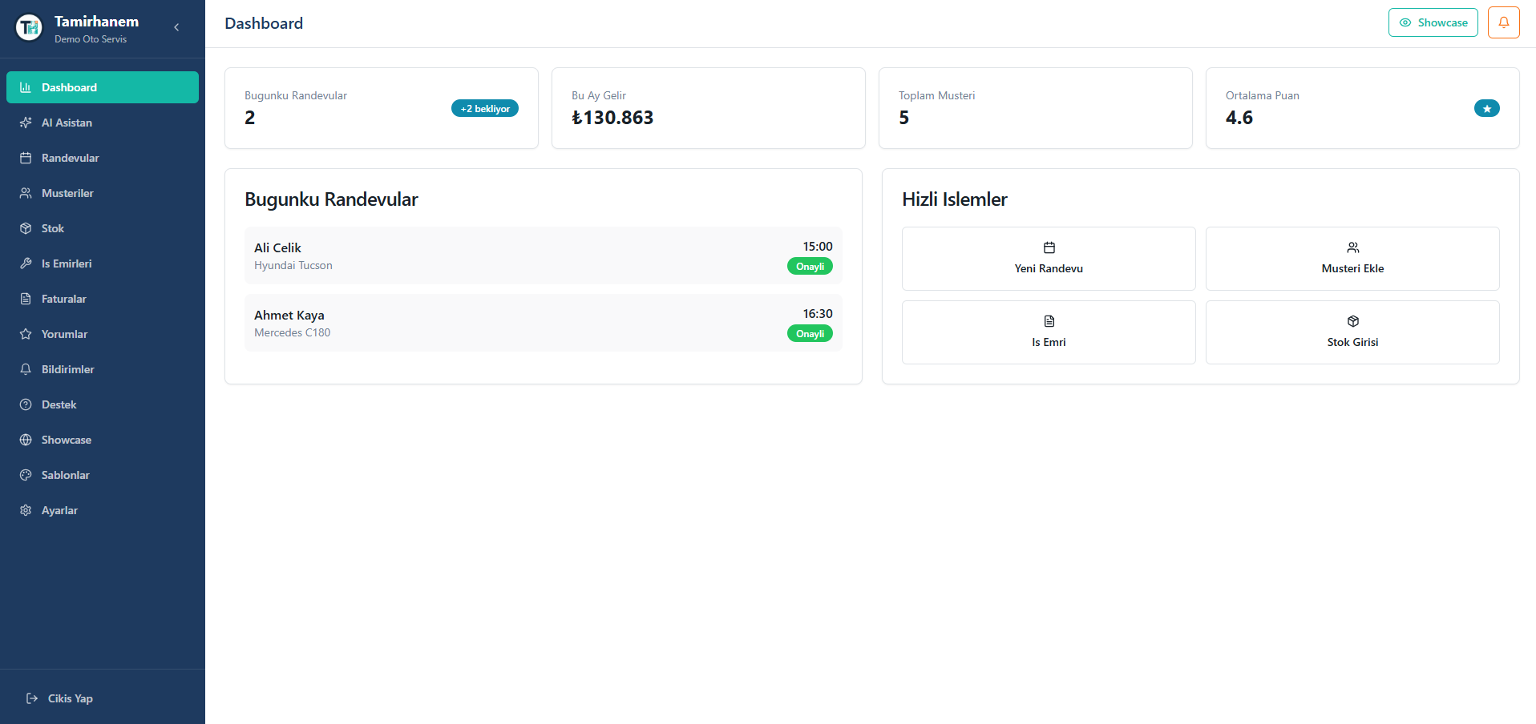Figure 4.8
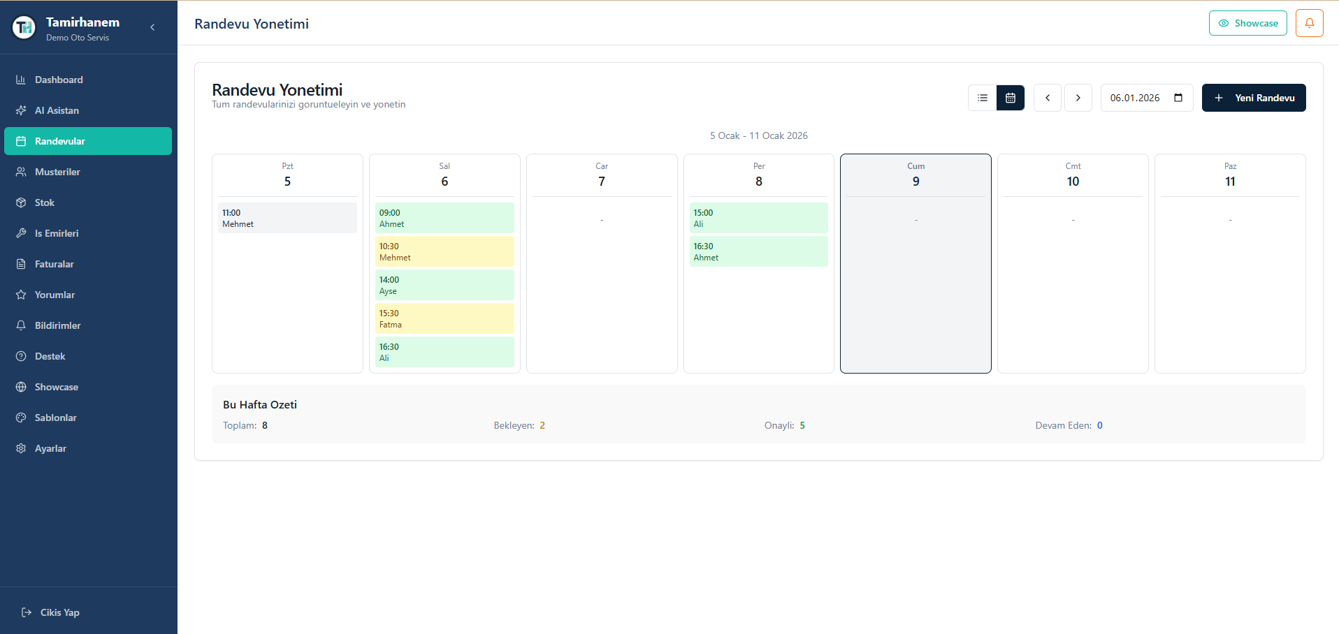Figure 4.9
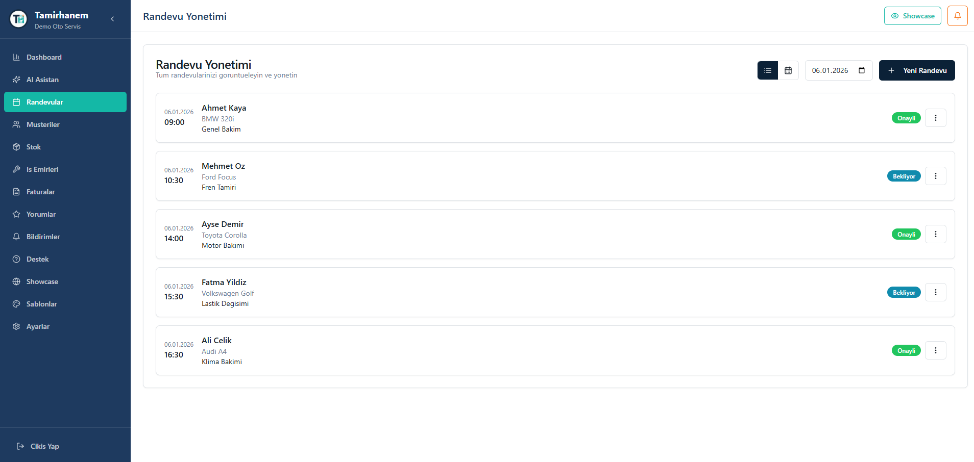Figure 4.10
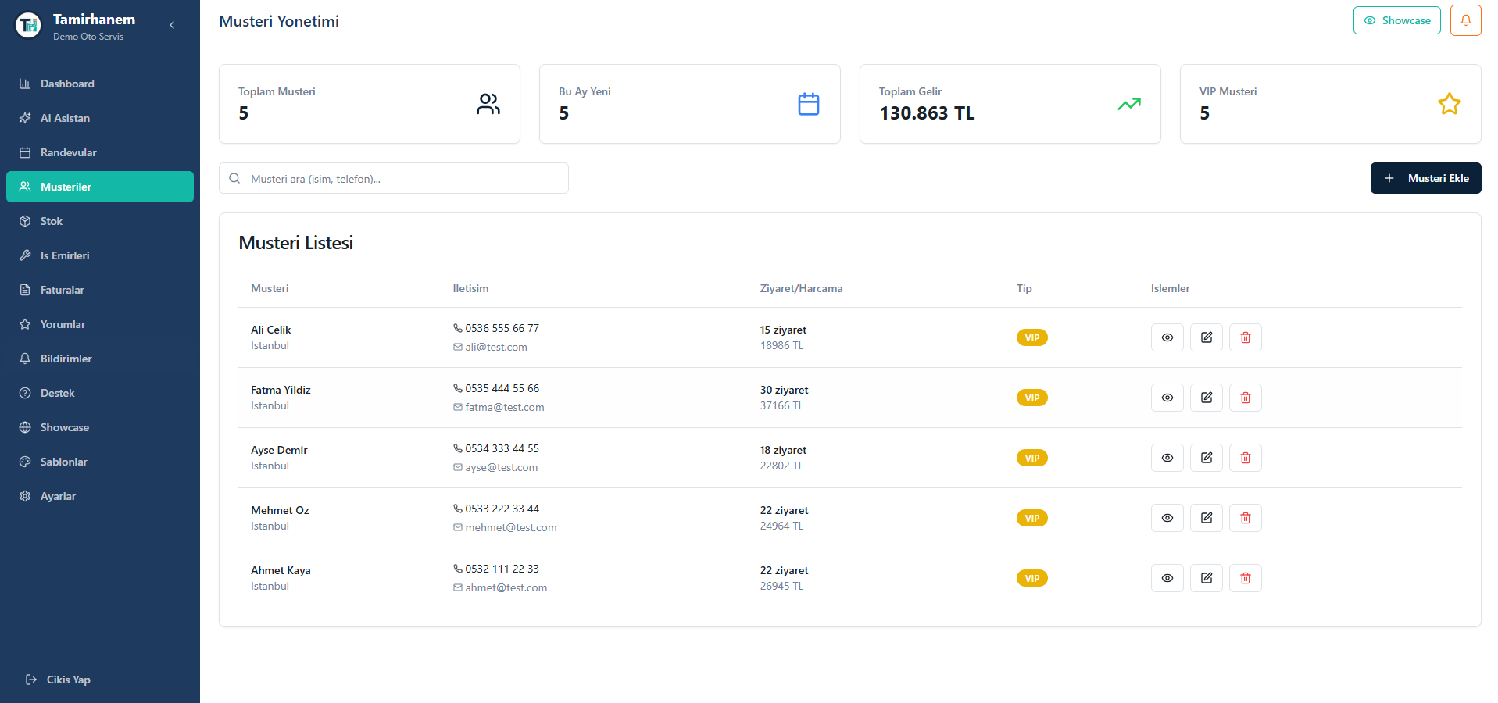Figure 4.11
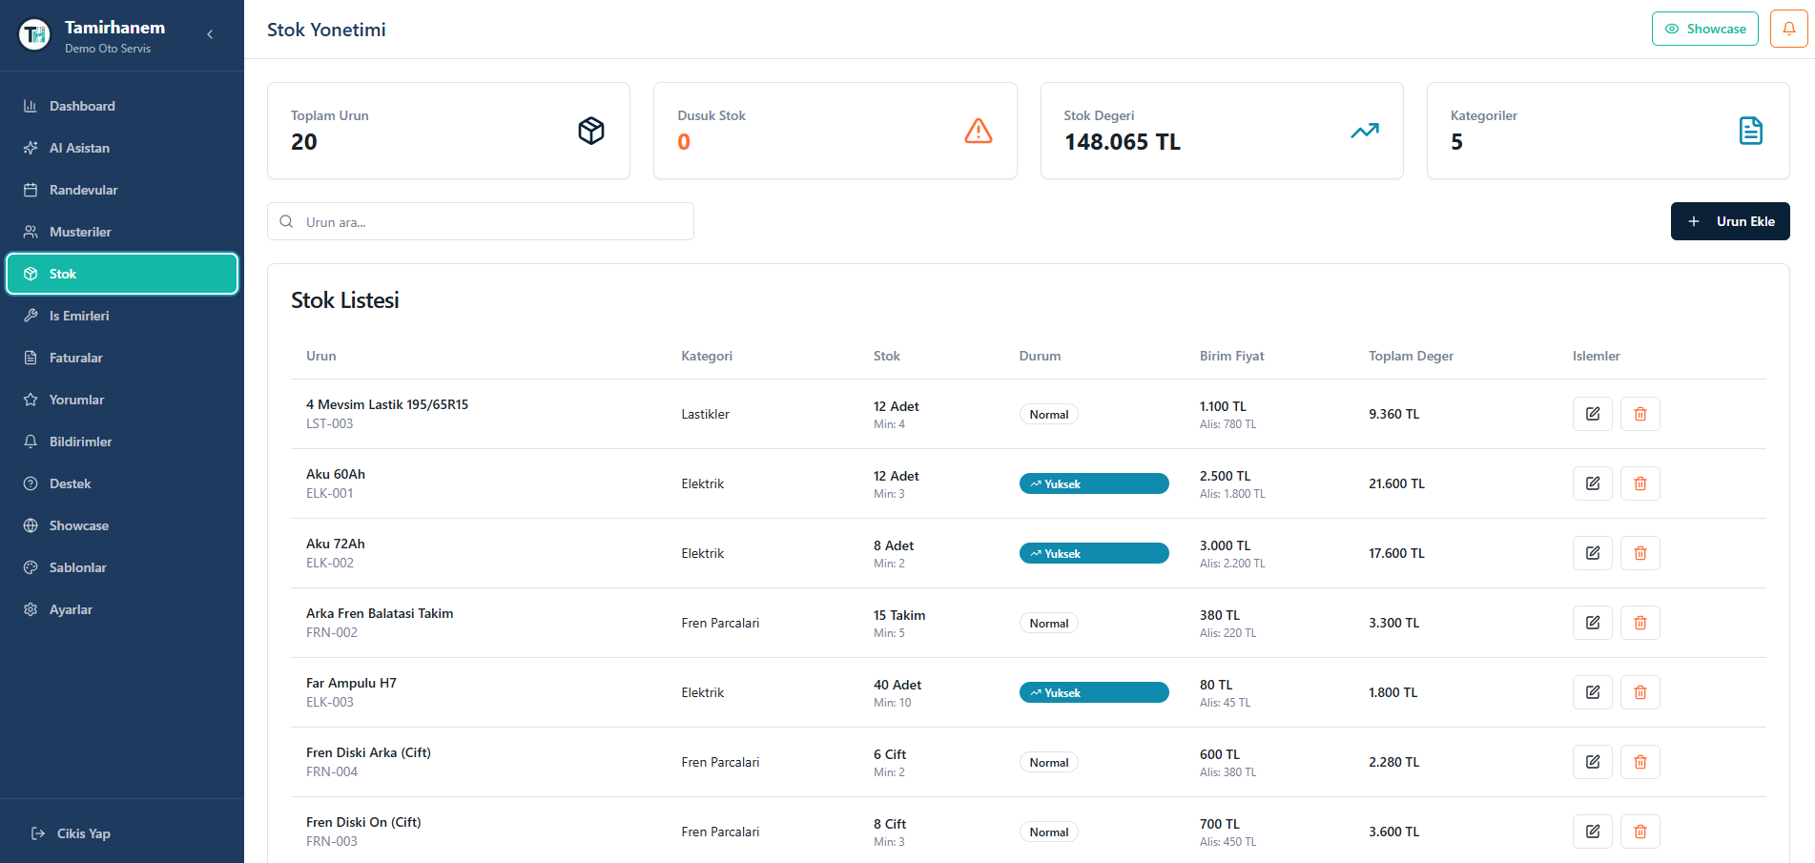Figure 4.12
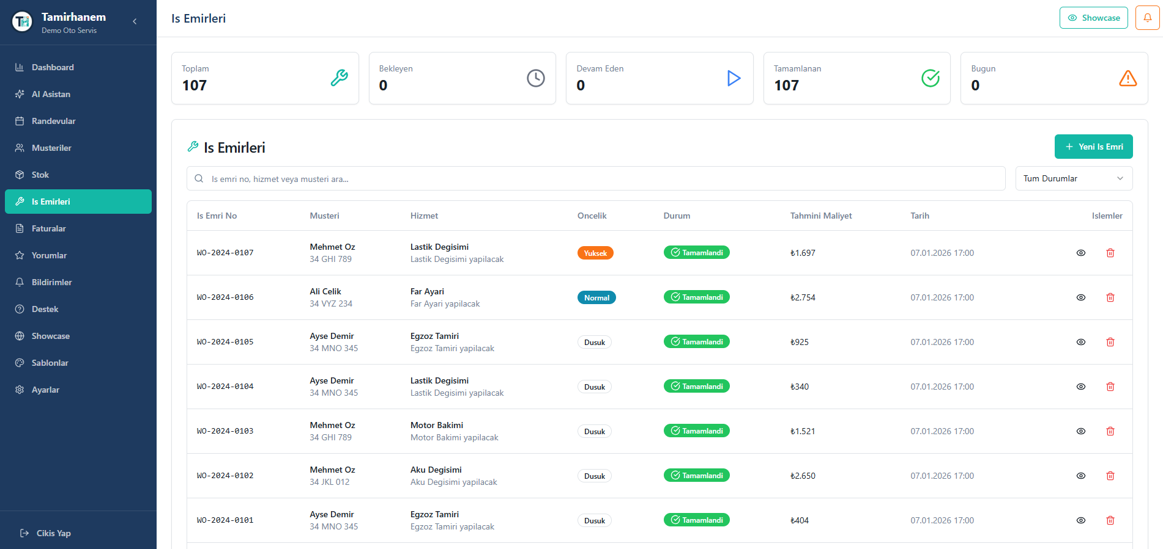Figure 4.13
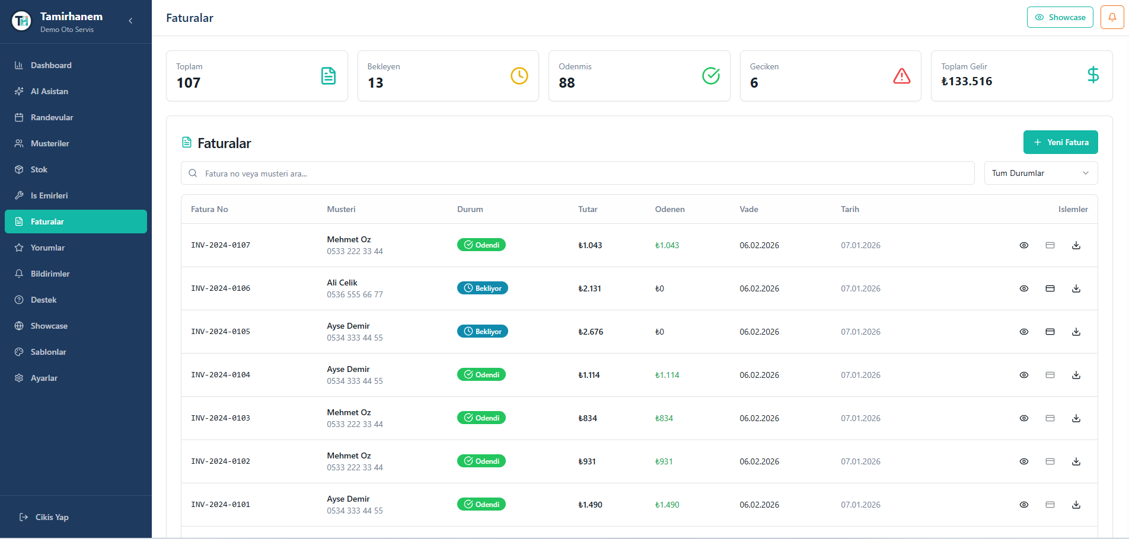Figure 4.14
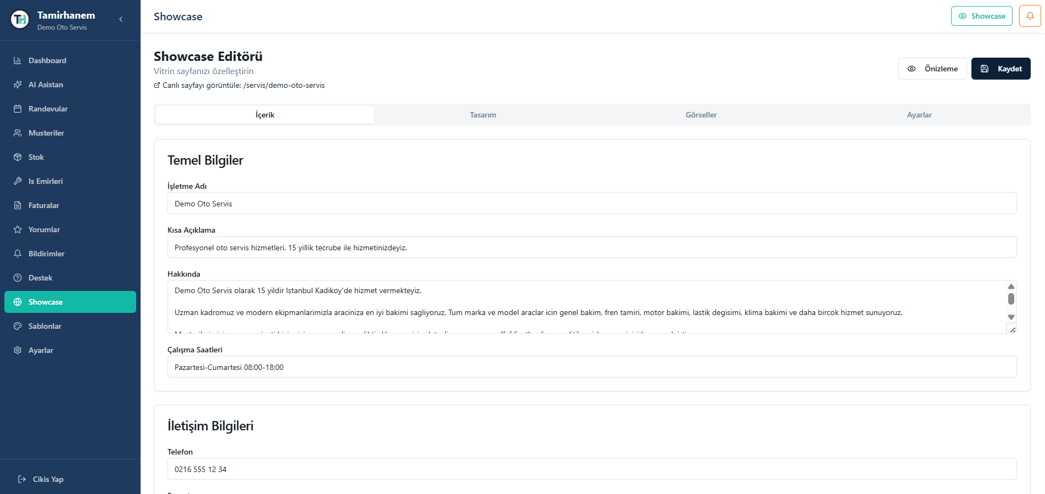Figure 4.15

4.6 CUSTOMER PANEL FEATURES
The customer panel, developed by Şevval Nur KASAVET, provides vehicle owners with a convenient interface for managing their service appointments, vehicles, and interactions with auto service businesses.
Table 4.3: Customer Panel Modules
Module | Description | Key Features
Dashboard | Personal overview | Active appointments, vehicles, reminders, pending invoices
Appointment Booking | Service scheduling | Business selection, date/time picker, service type, vehicle selection
Appointments | Appointment management | List view, status tracking, cancellation, rescheduling
Vehicles | Vehicle database | Add, edit, delete vehicles, vehicle details
Service History | Past services | Completed services, work details, costs
Invoices | Billing view | Invoice list, status, PDF download
Reminders | Maintenance alerts | Upcoming maintenance, custom reminders
Notifications | Communication center | All notifications, read status, filtering
AI Assistant | Intelligent help | Vehicle questions, recommendations, image analysis
Support | Help requests | Ticket creation, history, responses
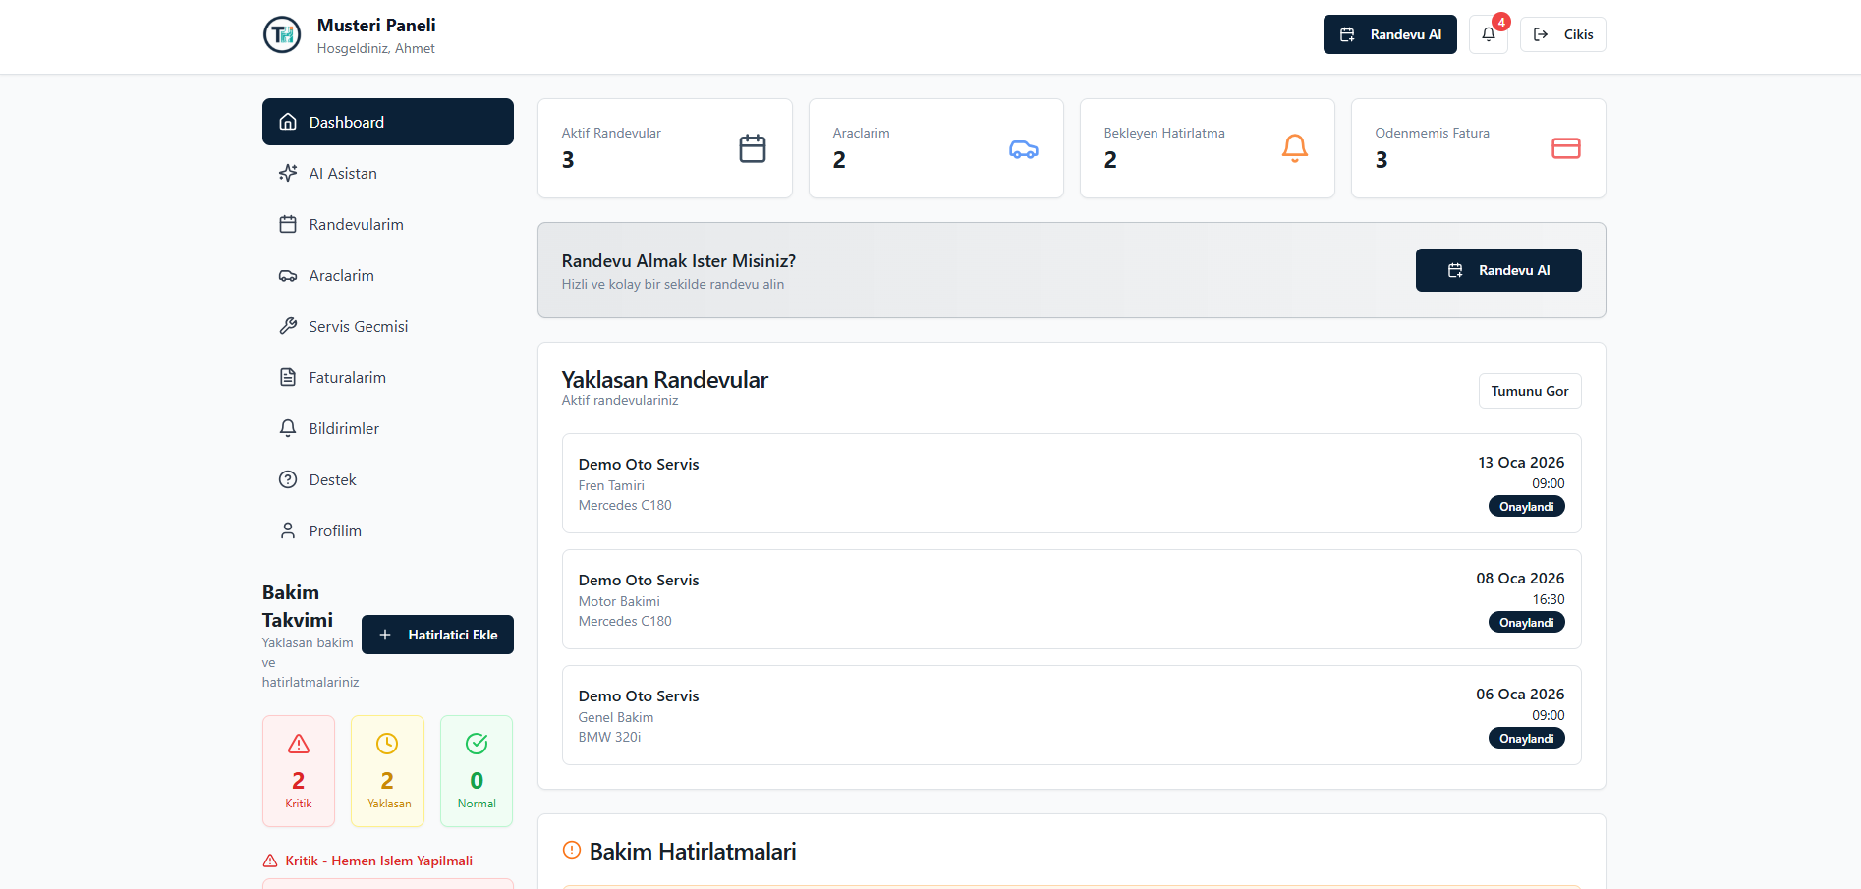Figure 4.16
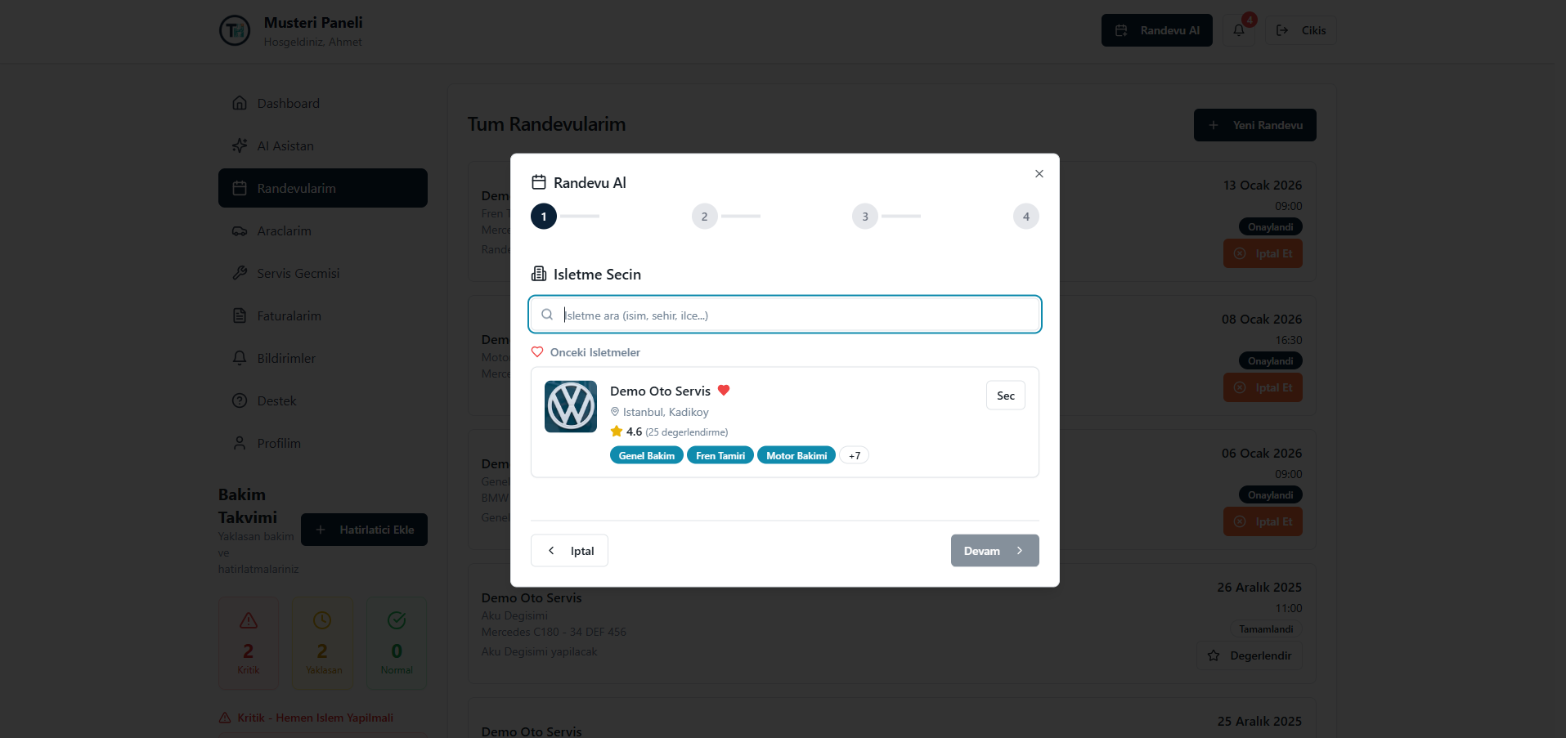Figure 4.17
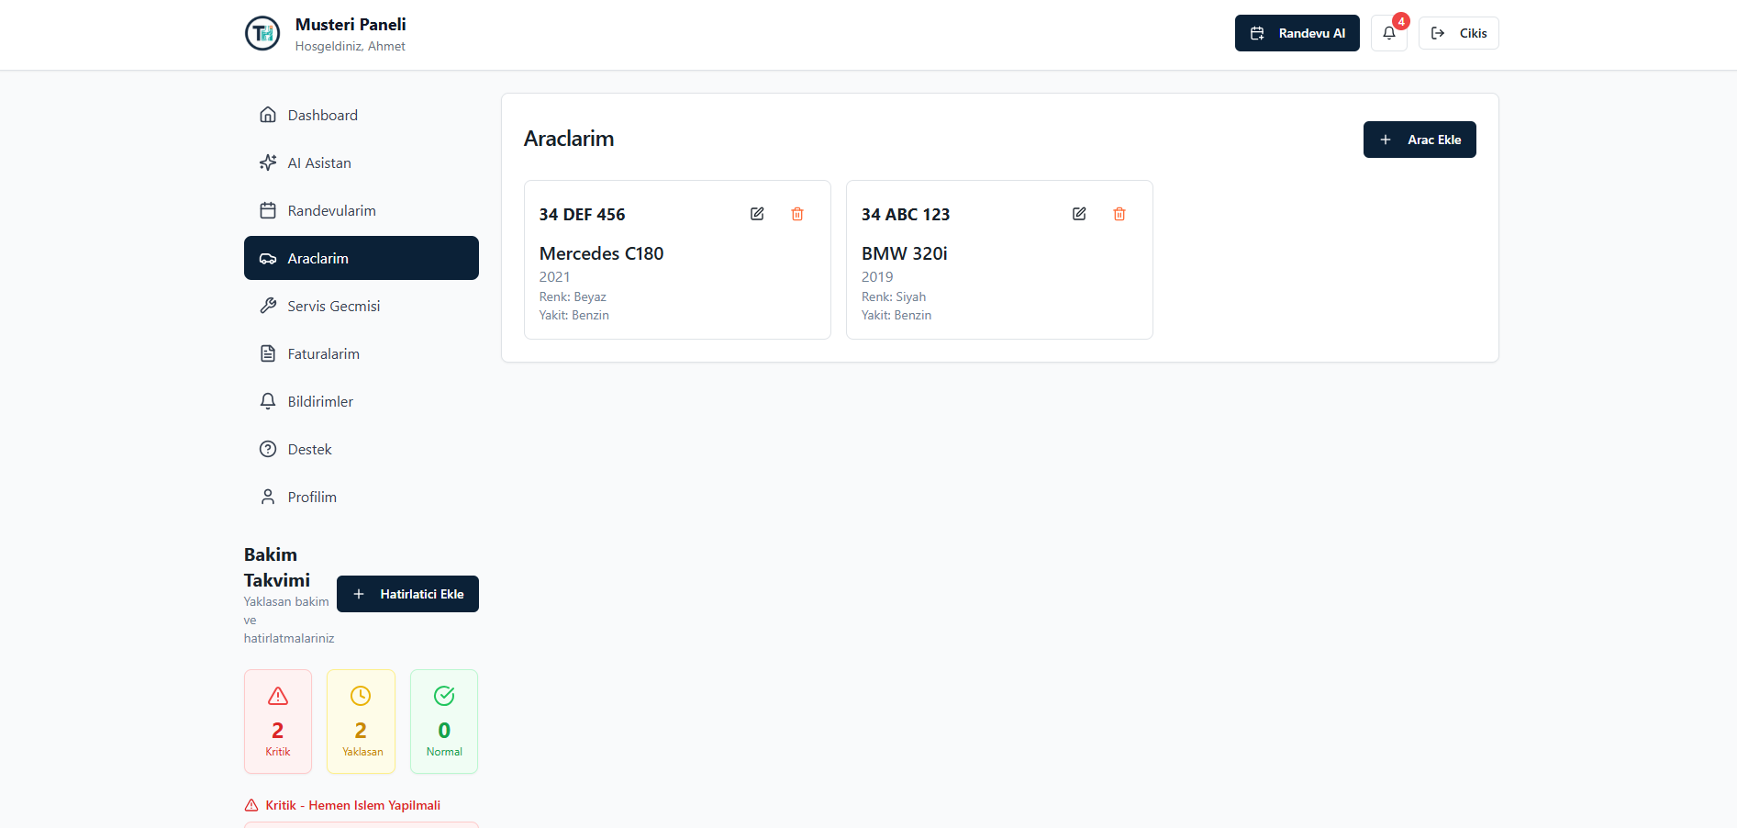Figure 4.18
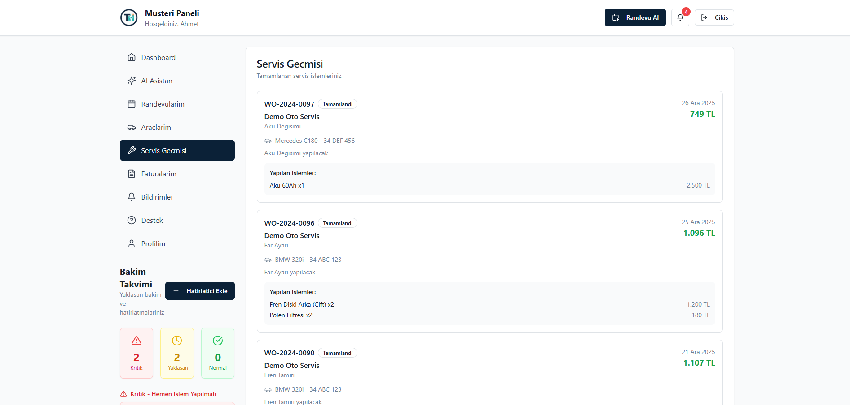Figure 4.19
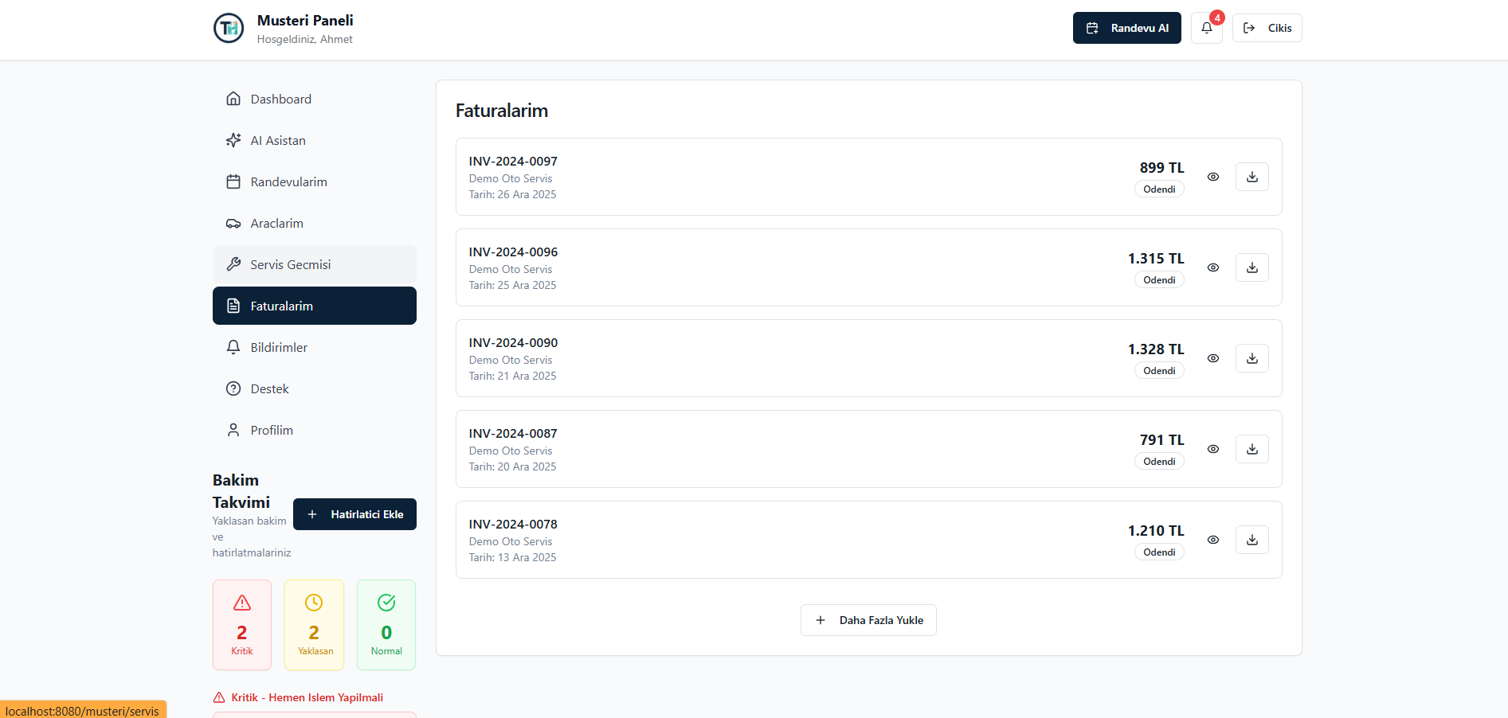Figure 4.20

4.7 AI ASSISTANT IMPLEMENTATION
The AI assistant feature represents an innovative aspect of the Tamirhanem platform, utilizing Google's Gemini API to provide intelligent support for both customers and business operators.

4.7.1 Customer AI Assistant
The customer AI assistant is designed to answer vehicle-related questions, provide maintenance recommendations based on service history, explain service requirements, and perform preliminary visual analysis of vehicle images to identify potential issues. The assistant maintains context awareness by accessing the customer's vehicle information, appointment history, and service records.

4.7.2 Business AI Assistant
The business AI assistant supports service operators with operational queries including customer information lookup, work order and inventory status reports, financial summaries, appointment information, unpaid invoice alerts, and low stock warnings. The assistant can synthesize data from multiple sources to provide comprehensive business insights.

4.7.3 Technical Implementation
The AI implementation comprises two main service components. The AI Assistant Service handles communication with the Gemini API, managing prompt construction, response parsing, and rate limiting (15 requests per minute). The AI Context Service retrieves relevant data from the database to provide context for AI responses, ensuring that answers are personalized and accurate.
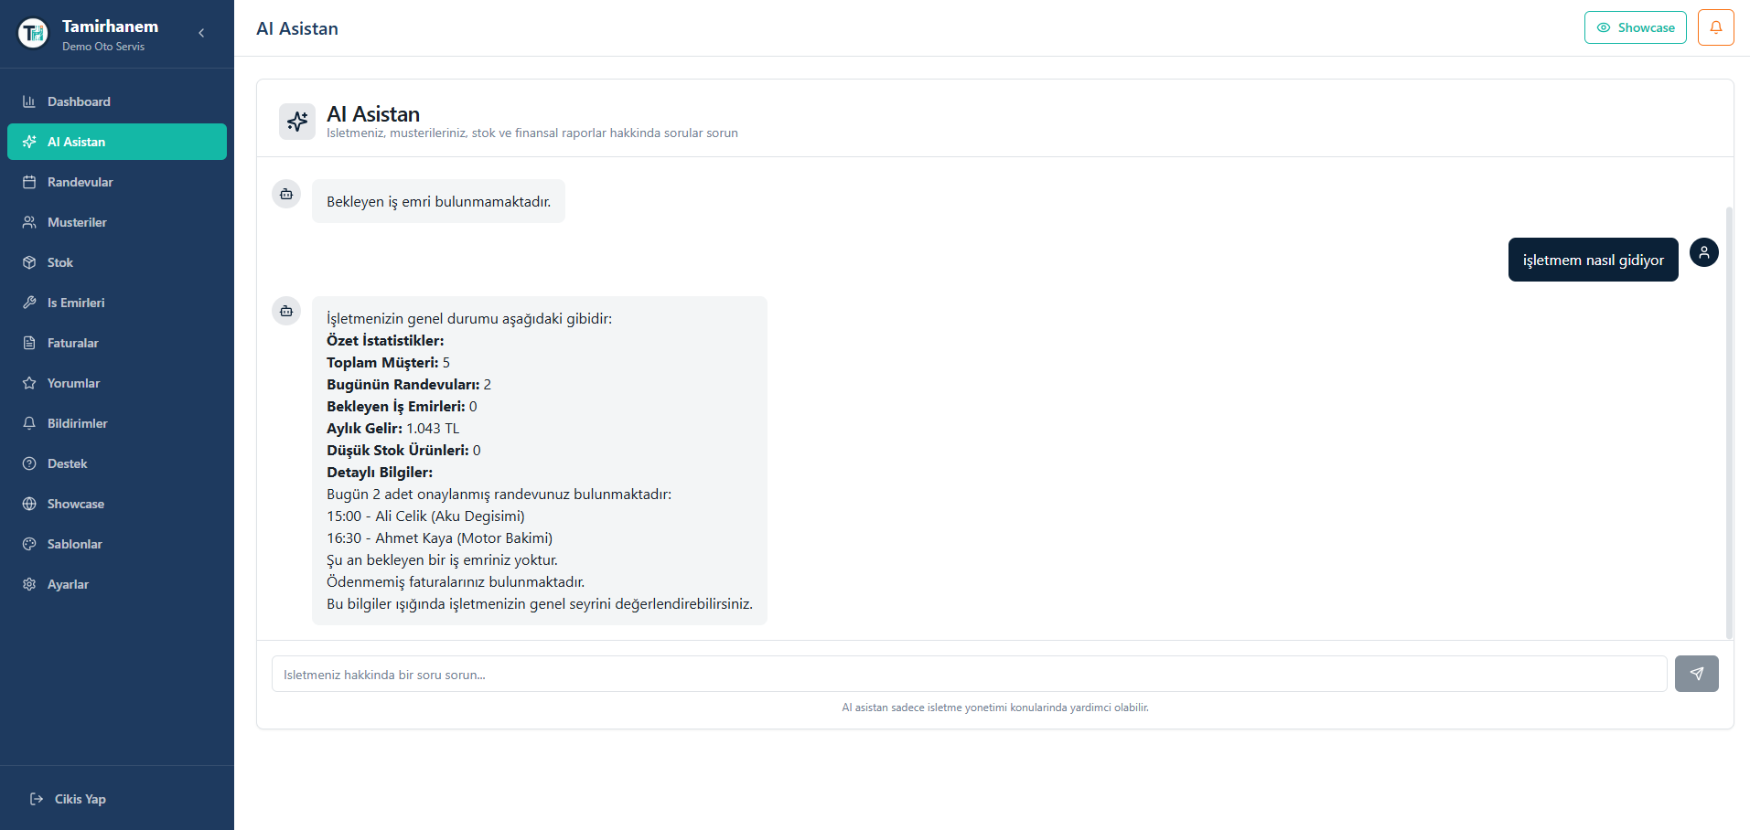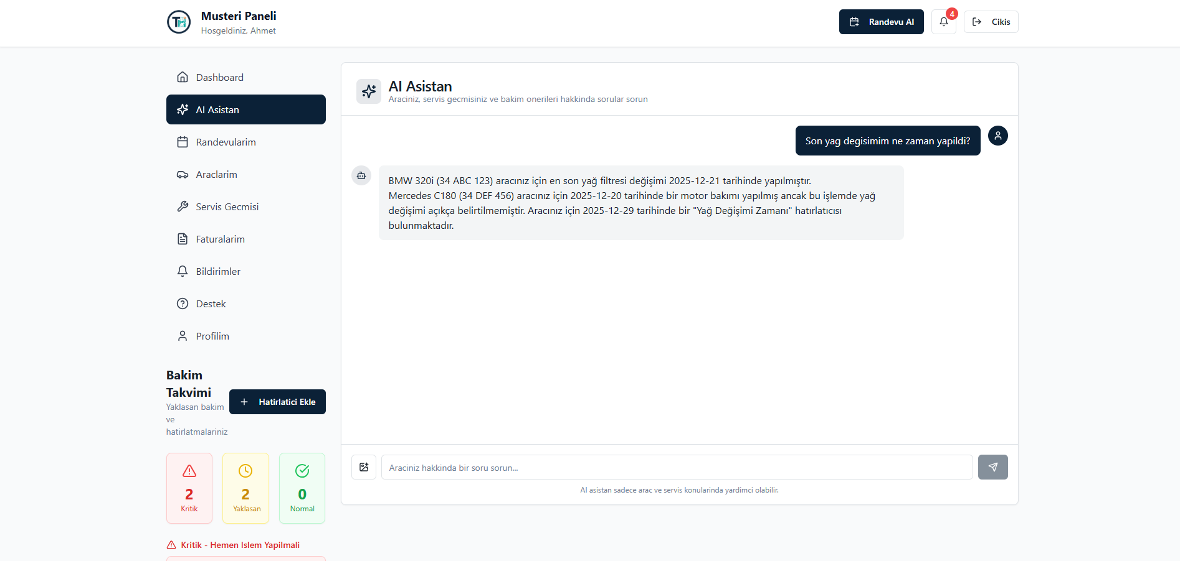
Figure 4.21
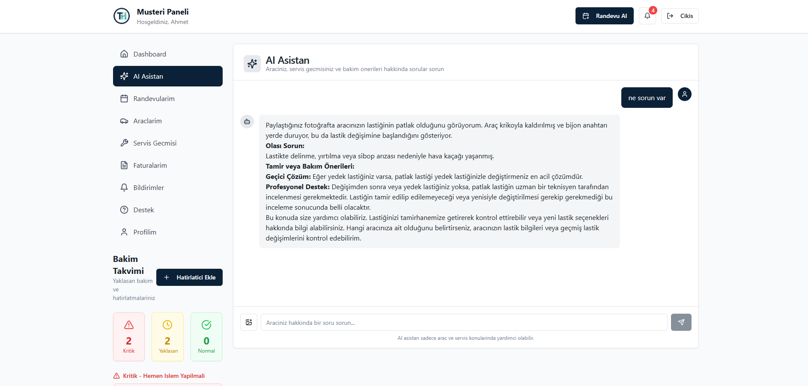Figure 4.22

5. TESTING AND EVALUATION
This chapter presents the testing strategy employed for the Tamirhanem platform and evaluates the system's performance against defined metrics and requirements.

5.1 TESTING STRATEGY
Quality assurance for Tamirhanem followed a practical testing approach suited to our team size and timeline. Şevval Nur KASAVET coordinated systematic testing across all three panels, documenting test cases in GitHub Issues and verifying fixes through follow-up testing. Each major feature underwent functional verification, cross-browser checks, and responsive layout testing before merging to the main branch.
Test cases were documented and tracked using GitHub Issues, enabling systematic coverage of all platform features. Code reviews were conducted for all pull requests, providing an additional layer of quality control before code integration.

5.2 FUNCTIONAL TESTING
Functional testing verified that all platform features operate according to specifications. Test scenarios covered the complete user journey for each role, from registration through core functionality usage.
Table 5.1: Test Scenarios and Results
Category | Test Scenario | Result
Registration | Customer registration with valid data | PASS
Registration | Business registration with valid data | PASS
Registration | Registration with invalid email format | PASS
Registration | Registration with weak password | PASS
Authentication | Login with correct credentials | PASS
Authentication | Login with incorrect password | PASS
Authentication | Token refresh on expiry | PASS
Authentication | Logout and token invalidation | PASS
Appointments | Create appointment with valid data | PASS
Appointments | Update appointment status | PASS
Appointments | Cancel appointment | PASS
Work Orders | Create work order from appointment | PASS
Work Orders | Add items to work order | PASS
Work Orders | Complete work order | PASS
Invoices | Generate invoice from work order | PASS
Invoices | Download invoice PDF | PASS
Invoices | Record payment | PASS
Stock | Add stock item | PASS
Stock | Record stock movement | PASS
AI Assistant | Customer chat query | PASS
AI Assistant | Image analysis request | PASS

5.3 USER INTERFACE TESTING
User interface testing ensured consistent functionality and appearance across different browsers and device sizes.

5.3.1 Cross-Browser Testing
The platform was tested on major web browsers including Google Chrome, Mozilla Firefox, Apple Safari, and Microsoft Edge. All core functionalities operated correctly across these browsers, with minor visual variations addressed through CSS normalization.

5.3.2 Responsive Design Testing
Responsive design testing verified the platform's usability across different screen sizes: desktop (1920x1080), laptop (1366x768), tablet (768x1024), and mobile (375x667). The UI adapts appropriately to each viewport, maintaining usability and visual appeal.

5.3.3 Accessibility Testing
Basic accessibility testing was conducted to ensure keyboard navigation functionality, adequate color contrast ratios, and semantic HTML structure. The use of shadcn/ui components built on Radix UI primitives provides inherent accessibility features including ARIA attributes and keyboard interaction patterns.

5.4 PERFORMANCE EVALUATION
Performance testing measured the system's responsiveness and efficiency against defined targets.
Table 5.2: Performance Metrics
Metric | Target | Actual | Status
API Response Time (average) | < 200ms | ~150ms | ACHIEVED
Frontend Initial Load | < 3 seconds | ~2.5 seconds | ACHIEVED
Database Query Time | < 100ms | ~50ms | ACHIEVED
PDF Generation Time | < 2 seconds | ~1.5 seconds | ACHIEVED
AI Response Time | < 5 seconds | ~3 seconds | ACHIEVED
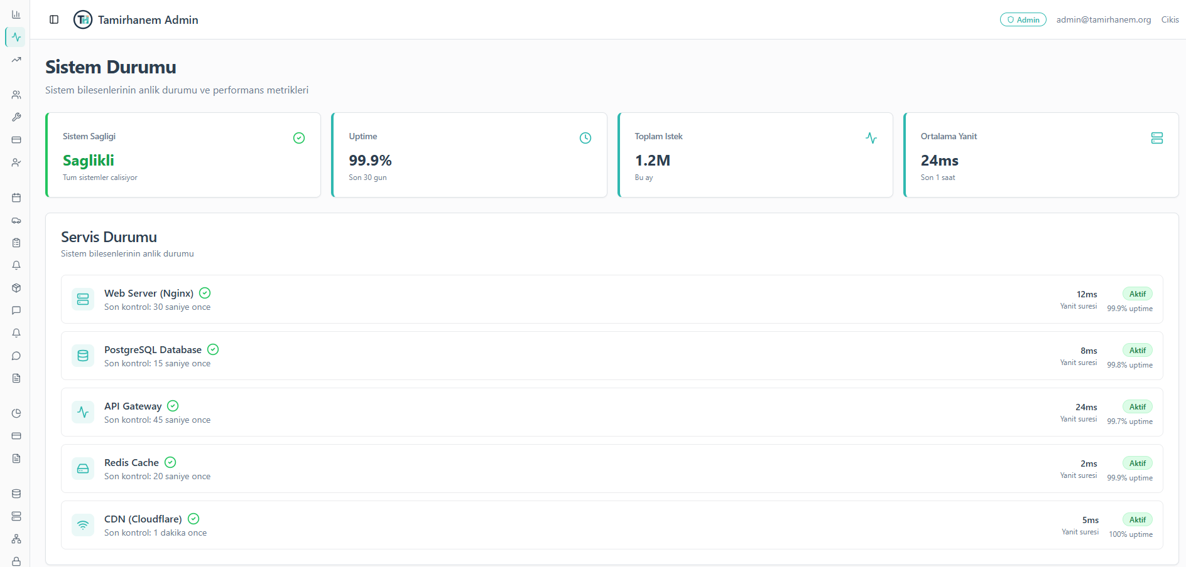Figure 5.1

6. CONCLUSION AND FUTURE WORK
This chapter summarizes the achievements of the Tamirhanem project, acknowledges its limitations, and outlines directions for future development.

6.1 PROJECT SUMMARY
The Tamirhanem project successfully delivered a comprehensive web-based platform for auto service management, addressing the identified challenges of digital transformation in the Turkish automotive service industry. The platform serves three distinct user roles with dedicated interfaces and functionality.
The development effort resulted in a fully functional system comprising over 200 API endpoints, 21 database tables, 141 frontend components, and integration with Google's Gemini AI for intelligent assistance. The platform demonstrates the viability of modern web technologies for creating sophisticated business management solutions.

6.2 ACHIEVEMENTS
Table 6.1 summarizes the achievement of project objectives defined in Chapter 1.
Table 6.1: Project Achievement Summary
Objective | Status | Notes
Digital appointment management system | COMPLETED | List and calendar views, status management
Customer Relationship Management (CRM) | COMPLETED | Customer database, vehicle history, contact tracking
Enterprise Resource Planning (ERP) | COMPLETED | Inventory, suppliers, stock movements, alerts
Work order management system | COMPLETED | Full lifecycle tracking, parts integration
Invoicing with PDF generation | COMPLETED | Automatic calculation, PDF export, payments
Business showcase pages | COMPLETED | Three templates, customization, publishing
AI-powered assistant | COMPLETED | Customer and business support, image analysis
Secure platform architecture | COMPLETED | JWT auth, RBAC, input validation, security headers

6.3 LIMITATIONS
Despite the successful implementation of core features, the current version of Tamirhanem has several limitations that should be acknowledged.
The platform currently lacks native mobile applications for iOS and Android. While the web interface is responsive and mobile-friendly, dedicated mobile apps would provide better user experience and access to device-specific features such as push notifications and camera integration.
Online payment integration is not included in the current version. Businesses must record payments manually, and customers cannot pay invoices directly through the platform. Integration with Turkish payment providers such as iyzico or PayTR would enhance the platform's utility.
SMS notification capabilities are absent, limiting the platform's ability to reach customers who may not regularly check email or platform notifications. Integration with SMS gateways would improve communication effectiveness.
The AI assistant, while functional, operates within rate limits and may experience latency during peak usage. The image analysis feature should be considered a preliminary assessment tool rather than a definitive diagnostic system.

6.4 FUTURE WORK
Based on the identified limitations and stakeholder feedback, the following areas are recommended for future development.
Mobile Application Development: Development of native mobile applications using React Native would provide a consistent codebase while enabling platform-specific optimizations. Push notifications, offline capabilities, and camera integration would enhance the mobile user experience.
Payment Gateway Integration: Integration with Turkish payment providers would enable online invoice payment, automatic payment tracking, and potentially recurring payment support for subscription services.
SMS Gateway Integration: Adding SMS notification capabilities through providers such as Netgsm would improve communication reach, particularly for appointment reminders and urgent notifications.
Multi-Language Support: Implementation of internationalization (i18n) infrastructure would enable the platform to serve diverse user populations and potentially expand to international markets.
Advanced Analytics: Development of predictive maintenance algorithms, customer lifetime value calculations, and business benchmarking features would provide additional value for business operators seeking data-driven insights.

REFERENCES

[1] Turkish Automotive Aftermarket Association, "Turkish Automotive Aftermarket Report 2023," TAYSAD Publications, Istanbul, 2023.
[2] A. Yılmaz and B. Kaya, "Digital Transformation Challenges in Turkish SMEs: A Case Study of Automotive Service Sector," Journal of Business Research Turkey, vol. 15, no. 2, pp. 45-62, 2022.
[3] McKinsey & Company, "The Future of Automotive Aftermarket Services," McKinsey Insights, 2022. [Online]. Available: https://www.mckinsey.com/industries/automotive-and-assembly/
[4] O. Demir, "Impact of COVID-19 on Automotive Service Industry Digital Adoption," Transportation Research Procedia, vol. 58, pp. 234-241, 2021.
[5] Shop-Ware Inc., "Shop-Ware Auto Repair Software Documentation," 2024. [Online]. Available: https://www.shop-ware.com/
[6] Mitchell 1, "ProDemand and Manager SE Product Guide," Mitchell International, 2024.
[7] Market Research Turkey, "Automotive Service Software Market Analysis," MRT Publications, Istanbul, 2023.
[8] Meta Platforms, "React Documentation," 2024. [Online]. Available: https://react.dev/
[9] Z. Gao, C. Bird, and E. T. Barr, "To Type or Not to Type: Quantifying Detectable Bugs in JavaScript," in Proc. IEEE/ACM International Conference on Software Engineering (ICSE), pp. 758-769, 2017.
[10] A. Wathan and S. Schoger, "Tailwind CSS Documentation," Tailwind Labs, 2024. [Online]. Available: https://tailwindcss.com/docs
[11] Node.js Foundation, "Node.js Documentation," 2024. [Online]. Available: https://nodejs.org/docs/
[12] Express.js, "Express.js Guide," 2024. [Online]. Available: https://expressjs.com/
[13] Prisma, "Prisma Documentation," Prisma Data, Inc., 2024. [Online]. Available: https://www.prisma.io/docs/
[14] PostgreSQL Global Development Group, "PostgreSQL Documentation," 2024. [Online]. Available: https://www.postgresql.org/docs/
[15] J. Wei et al., "Emergent Abilities of Large Language Models," Transactions on Machine Learning Research, 2022.
[16] Google, "Gemini API Documentation," Google AI, 2024. [Online]. Available: https://ai.google.dev/docs
[17] Gartner, "AI in Customer Service: Market Guide," Gartner Research, 2023.
[18] S. Kumar and R. Singh, "Computer Vision Applications in Automotive Diagnostics: A Review," IEEE Access, vol. 11, pp. 45678-45692, 2023.
[19] K. Schwaber and J. Sutherland, "The Scrum Guide," Scrum.org, 2020. [Online]. Available: https://scrumguides.org/

APPENDIX A
DATABASE SCHEMA DETAILS
This appendix provides detailed information about the database schema used in the Tamirhanem platform.
A.1 USER MODEL
The User model is the central authentication entity. Fields: id (UUID, Primary Key), email (String, Unique), passwordHash (String), role (UserRole enum: ADMIN, INDUSTRIALIST, CUSTOMER), status (UserStatus enum: ACTIVE, INACTIVE, PENDING, SUSPENDED), emailVerified (Boolean), lastLogin (DateTime, nullable), createdAt (DateTime), updatedAt (DateTime).
A.2 CUSTOMER PROFILE MODEL
The CustomerProfile model extends User with customer-specific information. Fields: id (UUID, Primary Key), userId (Foreign Key to User, Unique), firstName (String), lastName (String), phone (String, nullable), address (String, nullable), city (String, nullable), notes (String, nullable), totalVisits (Int), totalSpent (Decimal), rating (Decimal), createdAt (DateTime), updatedAt (DateTime).
A.3 INDUSTRIALIST PROFILE MODEL
The IndustrialistProfile model contains business information for service providers. Key fields include: businessName, ownerName, phone, email, address, city, district, taxNumber, description, logoUrl, coverImageUrl, website, workingHours (JSON), services (String array), subscriptionPlan, subscriptionStatus, slug (unique URL identifier), showcaseEnabled, showcaseTemplate, showcaseStatus, showcaseData (JSON), averageRating, and totalReviews.
A.4 COMPLETE TABLE LIST
The complete database schema includes 21 tables: User, CustomerProfile, IndustrialistProfile, Vehicle, Appointment, Category, Supplier, StockItem, StockMovement, WorkOrder, WorkOrderItem, Invoice, InvoiceItem, Payment, RefreshToken, Review, MaintenanceReminder, Notification, SupportTicket, TicketResponse, and Setting.

APPENDIX B
API ENDPOINTS REFERENCE
This appendix provides a reference list of the API endpoints implemented in the Tamirhanem platform.
B.1 AUTHENTICATION ENDPOINTS (/api/auth)
POST /api/auth/register - User registration
POST /api/auth/login - User authentication
POST /api/auth/refresh - Token refresh
POST /api/auth/logout - User logout
GET /api/auth/me - Current user profile
PUT /api/auth/profile - Update profile
B.2 APPOINTMENT ENDPOINTS (/api/appointments)
GET /api/appointments - List all appointments
POST /api/appointments - Create appointment
GET /api/appointments/:id - Get appointment details
PATCH /api/appointments/:id/status - Update status
GET /api/appointments/stats - Appointment statistics
B.3 AI ASSISTANT ENDPOINTS (/api/ai)
POST /api/ai/customer/chat - Customer AI chat
POST /api/ai/customer/chat-with-image - Chat with image analysis
POST /api/ai/industrialist/chat - Business AI chat

APPENDIX C
TEAM RESPONSIBILITIES MATRIX
This appendix provides a detailed breakdown of the responsibilities assigned to each team member during the project development.
C.1 ŞEVVAL NUR KASAVET (210502087)
Primary Responsibility: Customer Panel Development and Quality Assurance. Developed all customer-facing modules including dashboard, appointment booking, vehicle management, service history, invoice viewing, maintenance reminders, notification center, profile management, AI assistant interface, and support ticket system. Led quality assurance activities including functional testing, UI/UX testing, cross-browser testing, responsive testing, user flow testing, and regression testing.
C.2 YAMAÇ BEZİRGAN (200502023)
Primary Responsibility: Admin Panel and Backend Infrastructure. Developed the complete admin panel including dashboard, user management, business management, showcase management, appointment overview, invoice management, revenue reports, support tickets, notification management, and platform settings. Designed and implemented the backend architecture including RESTful API design, JWT authentication system, role-based access control, Prisma schema design (21 tables), Express middleware chain, error handling standards, and security configurations.
C.3 BEKİR ÇAKIR (210502084)
Primary Responsibility: Business (Industrialist) Panel Development. Developed all business panel modules including dashboard, appointment management (list and calendar views), customer management (CRM), inventory management (ERP), work order system, invoice management with PDF generation, review management, notification center, showcase editor, and settings. Implemented backend services for work orders, invoices, stock management, and review handling.
C.4 SHARED RESPONSIBILITIES
All team members collaborated on: project architecture decisions, technology stack selection, coding standards establishment, Git workflow and branch strategy, code review processes, UI/UX design decisions, landing page development, login/register page development, component library selection and customization, and responsive design implementation.

